“DON’T DRIVE IMPAIRED” CAMPAIGN
AUGUST 2020

SOCIAL MEDIA MESSAGES/GRAPHICS

Here are sample messages and graphics that you can incorporate into your social media. Feel free to adapt locally–statistics on impairment in your county can be found here and a suggested accompanying message on this page. For posting on Facebook and Twitter, please visit (webpage here).

Everyone can prevent impaired driving. Most Washingtonians (81%) will intervene to prevent impaired driving when they can. Take action.  https://bit.ly/3gCfg23  #ImpairedDriving  #PlanBeforeYouParty | 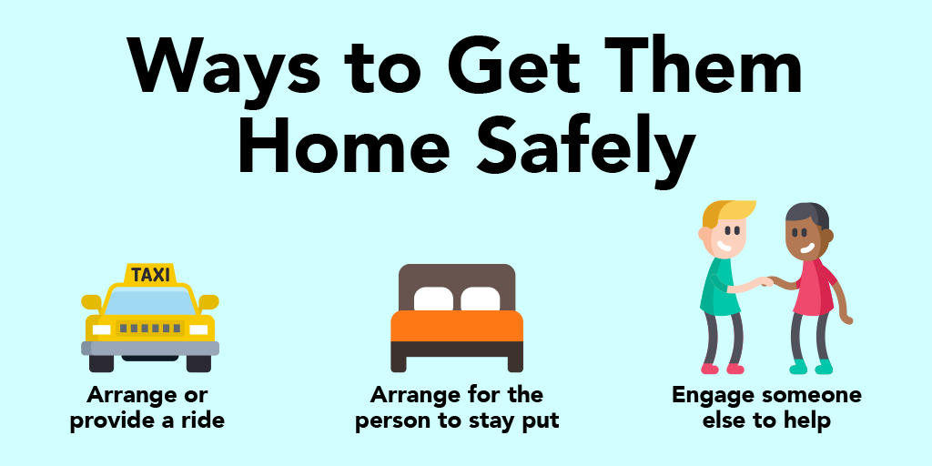
Most of us in Washington don’t drive impaired; the few that do were responsible for 231 fatal crashes in 2019.  https://bit.ly/3gCfg23  #DesignatedDriver  #ImpairedDriving | 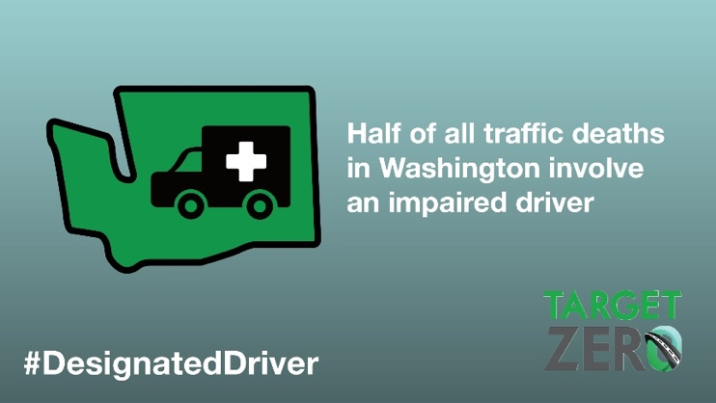
Law enforcement is conducting extra patrols to get impaired drivers off the road. Working together we can stop impaired driving. Plan before you party. Or help prevent someone from driving impaired.  https://bit.ly/3gCfg23  #DesignatedDriver  #ImpairedDriving | 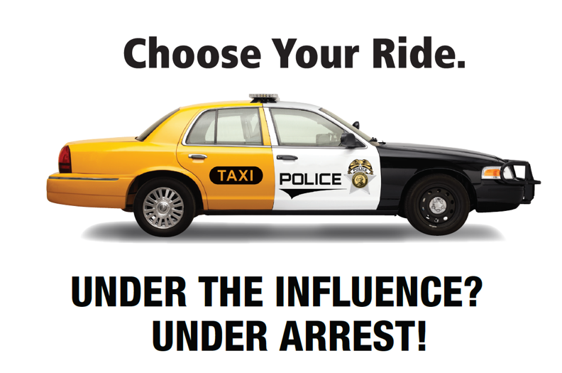
Take this simple quiz. So, how did you do?  https://bit.ly/3gCfg23  #DesignatedDriver  #ImpairedDriving | 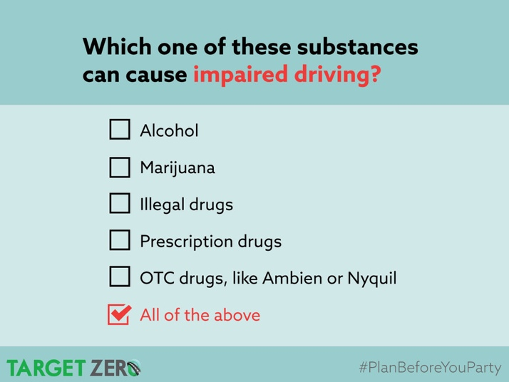
Most of us don’t drive impaired. We take responsibility and give our keys to someone before we party.  https://bit.ly/3gCfg23  #DesignatedDriver  #ImpairedDriving | 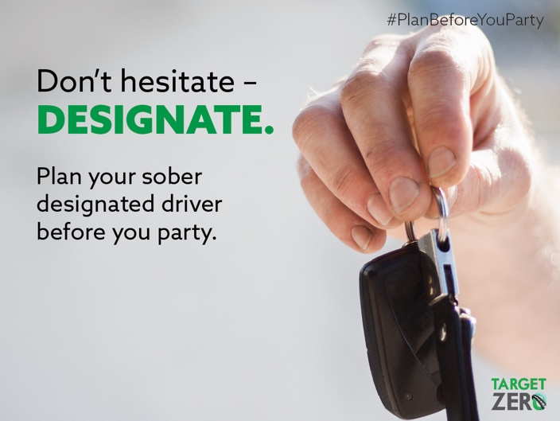
When there’s a chance to prevent someone from driving impaired, most Washingtonians (81%) will intervene and take action.  https://bit.ly/3gCfg23  #DesignatedDriver  #ImpairedDriving | 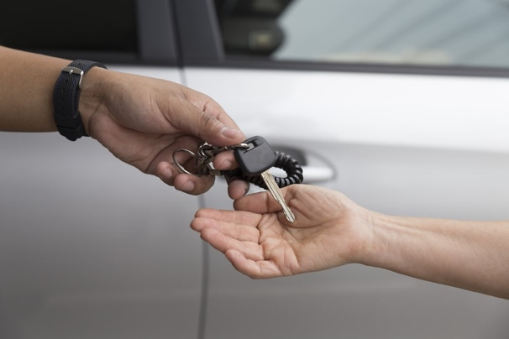

These materials include links to the DUI page on www.wadrivetozero.com/dui (WA Drive to Zero) for further information and resources. We encourage you to send your key audiences there.

# # #

