2020-2021 GRANT PROGRAM
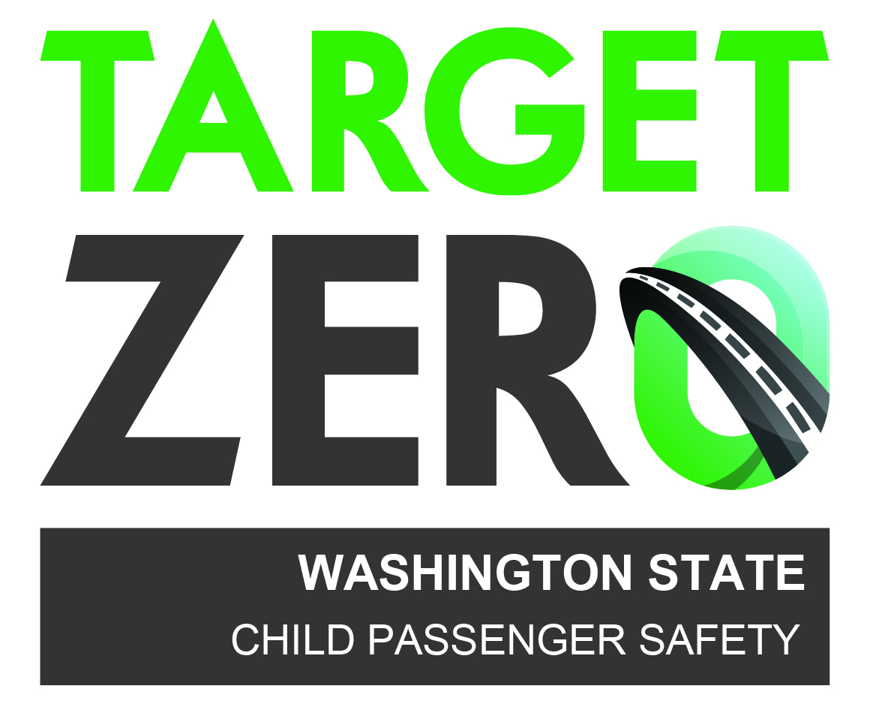
FOR
LOCAL CAR SEAT ACTIVITIES

Washington’s Child Passenger Safety Program is happy to announce the availability of mini-grants from $400.00 on up to $4,000.00 for activities intended to reduce the number of deaths and serious injuries to children resulting from traffic crashes on Washington roads.

NEW: Grant requests for hosting CPST courses will be done under a separate application.

Grant requests should be from a school, government agency or non-profit (501c3) organization within Washington State. All costs/expenses will be paid for by the grantee and billed for reimbursement. The proposal activities must demonstrate a direct link to one or more of the program goals.
GOAL #1: Increase visibility of child passenger safety issues in Washington.
GOAL #2: Maintain and support the statewide network of child passenger safety technicians and inspection stations.
GOAL #3: Strengthen efforts to increase compliance, enforcement, and adjudication of the seat belt and child restraint law.

- Each applicant certifies the Child Passenger Safety grant will not be used to replace existing state or local funds, defined as supplanting.
- Refer to the Requirements for Services to meet criteria to receive state funding.
- All projects must follow appropriate state and federal funding regulations.

FISCAL GRANT YEAR IS oCTOBER 1, 2020 THROUGH SEPTEMBER 30, 2021
aUGUST 15, 2020 | Distribution of Grant program
AUGUST 27, 2020 (11:00AM – 12:00PM) | Grant Proposal Webinar  Attendance is strongly encouraged; include agency fiscal person. Review of the grant process, tips, travel, reporting, evaluations,…
SEPTEMBER 15, 2020 5:00pm | Grant proposals due to WA CPS Program.  Must be signed by a person with contracting authority.
SEPTEMBER 15 - 30, 2020 | Review of proposals; notification of grant approval or decline by email.  Evaluation is based on Qualifications, Deliverables, and Budget.  Any funds not allocated will be provided to late submittals.
PROPOSED PROJECT COSTS

ALLOWED | NOT-ALLOWED
- CEU workshop  - Seat sign-offs  - Car Seat Awareness Class  - Equipment/materials for car seat inspections  - Educational material  - Car Seat Awareness class  - LATCH Manual(s) - limit the distribution of manuals to active car seat technicians who perform inspections on their own. Teams should have one or more available at inspection sites.  - Car and booster seats – up to a maximum of $2,000 per grantee  - Must be distributed by technician with education and training.  - Checklist completed for each seat distributed; archived for 3 years; then destroyed.  - Target those with demonstrated financial need (Headstart, ECEAP, Medicaid, etc.).  - Request a monetary donation for seat whenever possible. | - Rear-facing only seats  - Food/refreshments  - Office furniture  - Gifts (gift cards, flowers, etc.)  - Entertainment  - Construction  - Promotional, give-a-ways, or branding items  - Clothing  - Wages for technician/instructor attending a class, training or car seat event  - Vehicle fuel expenses for an agency car

THE GRANT APPLICATION PROCESS – EASY AS 1, 2, 3

- Read these grant policies and procedures in their entirety before applying.
- Generate your grant proposal including three sections (an example is provided):
QUALIFICATIONS = explain your agency’s involvement in child passenger safety (CPS) efforts. Include your work with traffic safety programs and experience managing public funds efficiently and ethically. Timely submission of quarterly activity reports will be considered.
DELIVERABLES = explain expected results from grant and how it will support the program’s goals. Include how you will collect, analyze and evaluate your efforts in addition to estimated dates of courses, classes, etc.
BUDGET = a detailed list of funding requirements to complete the project.
- Scan/email a signed proposal to Cesi Velez, Project Manager velezc@cobl.us Questions? 253-447-3257

Many grant submissions will include travel expenses for CPST Instructors/Technicians/Proxies to provide services. Review the following and ensure understanding of your service provider.

IMPORTANT REMINDERS REGARDING TRAVEL REIMBURSEMENT
For additional information visit https://ofm.wa.gov/accounting/administrative-accounting-resources/travel

Check mileage rate as it often changes on January 1st of each year.

50 mile rule
Reimbursement is allowed for lodging expenses when the temporary duty station is located more than fifty (50) miles (most direct route) of the closer of either the traveler’s residence or official station.

When may a traveler be reimbursed for meal costs?
10.40.50.a For overnight travel assignments, the agency-determined meal periods are used to determine when a traveler is entitled to a meal.
10.40.50.b For non-overnight travel assignments, the following two criteria must be met to receive a meal allowance:
1. Three Hour Rule – a traveler may be reimbursed for meal expenses only after the traveler is in travel status for three hours beyond the traveler’s regularly scheduled working hours for any one day. The three hours may consist of hours occurring before, after, or a combination of both before and after the traveler’s regularly scheduled working hours for the day.
2. In travel status during the entire meal period – travelers must be in travel status during the entire agency-determined meal period(s) in order to qualify to collect meal payments for meal(s), except as provided in subsection 70.15.10. The traveler may not stop for a meal just to meet the three-hour rule.

IMPORTANT NOTE:
The Washington traffic Safety Commission has designated meal periods; you must be in travel status at least 3 hours outside of your normal work schedule to be reimbursed for that meal; and be gone the entire meal period. The meal periods are:
Breakfast 6:30 to 8:00
Lunch 11:30 to 1:00
Dinner 5:30 to 7:00

If there is a question, contact the Project Manager (Cesi Velez) and resolve any issues before payment is made.

IMPORTANT DATES OF GRANT PROGRAM

JULY 20, 2021 | All invoices for goods received or services performed on or prior to June 30th, must be received by Cesi Velez, Project Manager.
OCTOBER 20, 2021 | All invoices for goods received or services performed between July 1st and September 30th, must be received by Cesi Velez, Project Manager.
SUBMIT PERIODIC INVOICES FOR REIMBURSEMENT AS DELIVERABLES ARE MET OR SERVICES PROVIDED.

SUBMITTING FOR REIMBURSEMENT

Submit the following documents in this order:
- A19 invoice –signed, complete, including State Wide Vendor number (SWV#).
- Copy of signed grant (NOT including this will delay reimbursement).
- Proof of payments made.
- When applicable, copies of invoices from service provider; Travel Expense Voucher, hotel receipt if lodging is included.
- When applicable, evaluations of services provided.

It is the grantee’s responsibility to ensure their payment of products/services is correct and for grant appropriate expenses.

Choose ONE method of sending to Cesi Velez, Project Manager:
- Scan/email to velezc@cobl.us
- Fax to 253-863-2661
- Mail to Bonney Lake Police Dept., 18421 Veterans Memorial Dr. E., Bonney Lake, WA 98391

DISPUTE REGARDING THE AGREEMENT
Disputes arising under this agreement shall be resolved by a panel consisting of one representative of the Washington Traffic Safety Commission, one representative from the Bonney Lake Police Department, one representative from your agency and a mutually agreed upon third party. This dispute panel shall thereafter decide the dispute with a majority prevailing.

terminatING the agreement
Either party may terminate this agreement upon (30) days of written notice to the other party. In the event of termination of this agreement, the terminating party shall be liable for the performance rendered prior to the effective date of termination.

