Seat Belts and Safety

Fact Sheet

Click-it or Ticket
- Extra seat belt enforcement patrols will be on Washington roadways from May 13 through June 2, including over the Memorial Day weekend, one of the busiest travel and holiday weekends of the year.
- More than 145 law enforcement agencies will put extra patrols on the road from May 13 to June 2.
- A ticket for not wearing your seat belt is $136 in Washington.

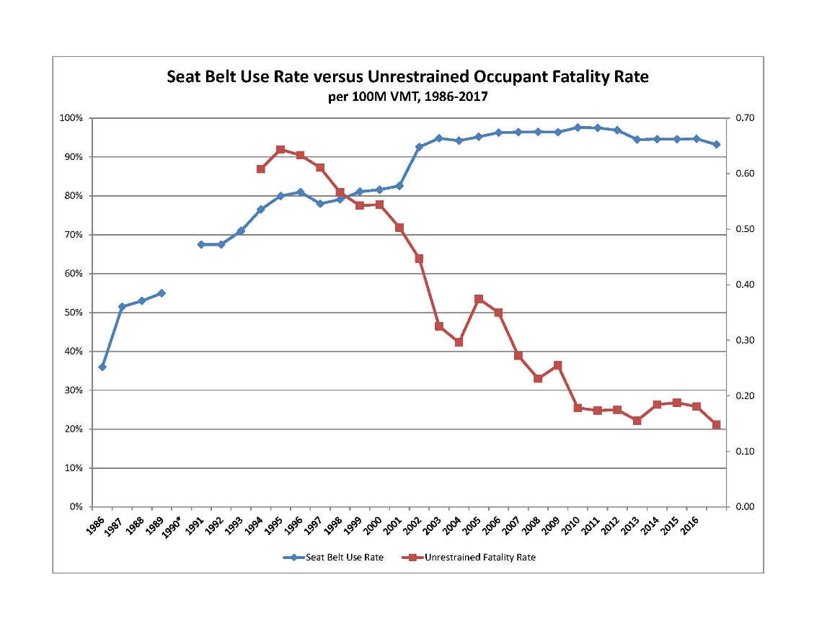
Buckle-up to Save Lives
- Your chances of dying in a car crash are four times greater if you don’t wear your seat belt.

- Fatalities of un-belted drivers or passengers have dropped as seat belt use has increased.

- Fewer unrestrained vehicle occupants died in Washington as seat belt use increased.

- Nationally, seat belts saved an estimated14,955 lives of occupants five and older. From 2013 to 2017, seat belts have saved nearly 69,000 lives.

Seat Belts Are Popular
- Almost everyone – 93.2% in Washington – buckles up. It’s the popular thing to do!

- Even among the group least likely to wear a belt, young males (18-24) more than 83% report always wearing a seat belt.

- Washington has one of the highest seat belt use rates in the nation at 93.2 percent, according to a 2018 WTSC study. The national rate was 89.7 percent, according to a National Traffic Safety Administration report (latest data available).

Who’s Not Wearing a Seat Belt?
- Among young adults age 18-to-34 killed in crashes in 2017, more than half (57%) were completely unrestrained – one of the highest percentages for all age groups.

- Seat belt compliance is lower on tribal lands in Washington. An observational study on one eastern Washington reservation found 62% seatbelt use overall, substantially less than the 92 percent in neighboring counties.

De-Bunking a False Sense of Security
It’s easy to buy-in to common misperceptions of security (statistics below are national):

Size Doesn’t Matter: If you’re not buckled, being in a pickup or other large vehicle isn’t safer. In fact, 61 percent of pickup truck occupants who were killed in 2016 were not buckled up. That’s compared to 42 percent of passenger car occupants who were not wearing seat belts when they were killed. Big truck or small car, seat belts are the safest bet.

Back Seats Won’t Protect You (only seat belts can do that): Too many people wrongly believe they are safe in the back seat unrestrained. Forty-seven percent of all front-seat passenger vehicle occupants killed in crashes in 2016 were unrestrained, but 57 percent of those killed in back seats were unrestrained. If you’re in the back, buckle-up.

Just as Important for Country Cousins as City Slickers: People who live in rural areas might believe that their crash exposure is lower, but in the U.S. in 2016, there were 13,732 passenger vehicle fatalities in rural locations, compared to 9,366 fatalities in urban locations. Out of those fatalities, 49 percent of those killed in the rural locations were not wearing their seat belts, compared to 46 percent in urban locations. Whether on busy city streets or a dusty rural road, buckle up to stay safe.

