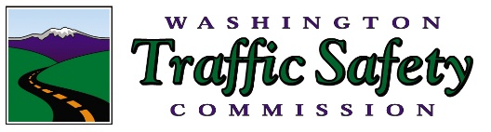
Super Bowl Sunday

Communications

Tool Kit

February 4 is Super Bowl Sunday, and WTSC is asking our Target Zero partners to help remind fans to plan ahead if they plan on drinking.
We’ve prepared a communications tool kit for your convenience to help encourage fans to use designated drivers or other strategies to help keep our roads free of impaired drivers. Enclosed in this tool kit you will find:
- Key messages: please incorporate these messages in your communications to your audience over the next few days
- Email/Website message: A sample message you can send to your constituency or post on your website
- Graphics: Football-themed graphics with our messaging you can incorporate into your communications
- Sample Social Media: Sample messages (with our graphics included) that you can incorporate into your social media. We’ve also included a suggested timeline
- WA Drive to Zero: These materials include links to the DUI page on www.wadrivetozero.com/dui for further information and resources and we encourage you to send your key audiences there.

Key Messages

Have a Super Bowl Party Game Plan
- Every Super Bowl Party and partier must have a game plan that prevents drunk or impaired driving.

- Getting a DUI or being involved in a crash is no way to end your Super Bowl Sunday.

- When it comes to our roads, everyone is an MVP, and everyone deserves to get home to their families safely.

- Make a game plan!
  - Choose a Designated Driver
  - Taxi or rideshare
  - Take public transportation
  - Spend the night
  - Leave your car at home
  - Download and use the Safer Ride app to your phone, which can help get you home safely

- Volunteer to be a designated driver. Show you’re a team player by offering friends a safe, sober ride home.

- If you’re hosting a Super Bowl party, be a good referee. Make the right call and take their keys before they drink and drive.

The Dangers of Drunk or Impaired Driving

- Drunk driving kills. In 2016 there were 10,497 fatalities in motor vehicle traffic crashes involving drunk drivers.

- Half of all traffic deaths in Washington involve an impaired driver.

- Driving while high doubles your chance of killing yourself or others in crash.

- There were 278 fatalities involving an impaired driving in Washington in 2016. Nearly 42% of those involved marijuana.

- Would you get in a car with someone who had difficulty steering, impaired perception and concentration, short-term memory loss and lack of speed control? These are all the effects on driving of someone who has a blood alcohol concentration of .08.

DUI Consequences

- $5,000 fine
- Legal bills of up to $10,000
- 100% increase in insurance rates
- One year in jail
- Suspended license
- Installation of ignition interlock device on your car
DUI Doesn’t mean just Alcohol
Impaired driving includes:
- Alcohol
- Marijuana
- Illegal drugs
- Prescription drugs
- Many over the counter drugs like Nyquil, Ambien, pain and allergy meds

Website/Email Message

NAME OF ORGANIZATION wants everyone to have an enjoyable and safe Super Bowl Sunday! If you’re planning or attending a Super Bowl Party, make sure you have a game plan for getting home safe! When it comes to our roads, everyone is an MVP, and everyone deserves to get home safely.
Make a Game Plan!
- Choose a Designated Driver
- Taxi or rideshare
- Take public transportation
- Spend the night
- Leave your car at home
- Download and use the Safer Ride app to your phone (download for Android or Apple), which can help get you home safely
For more information go to www.wadrivetozero.com/dui

Graphics

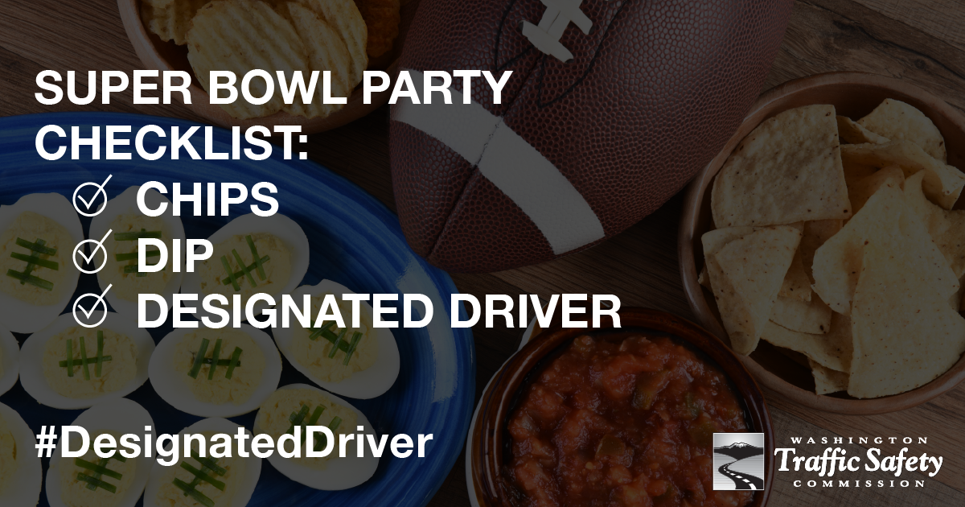

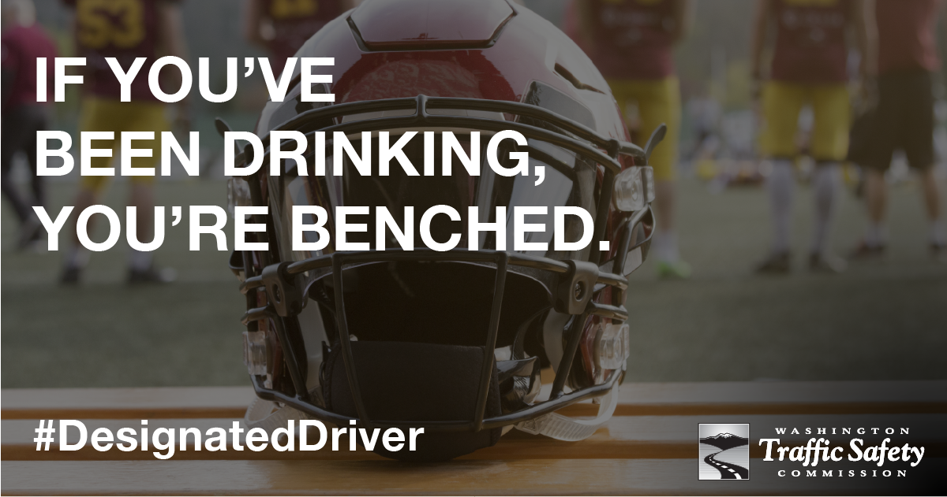

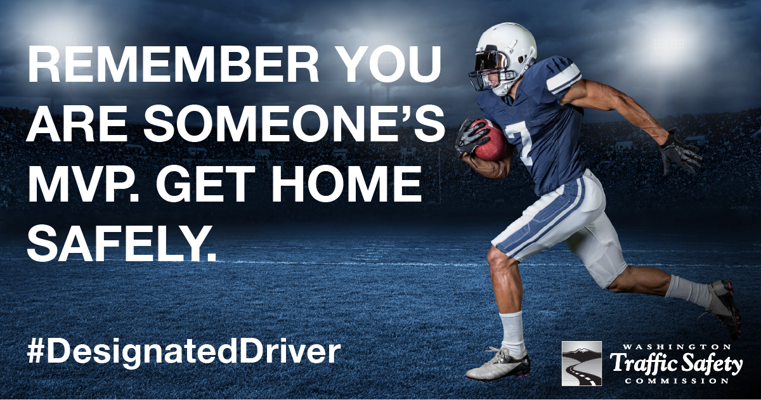

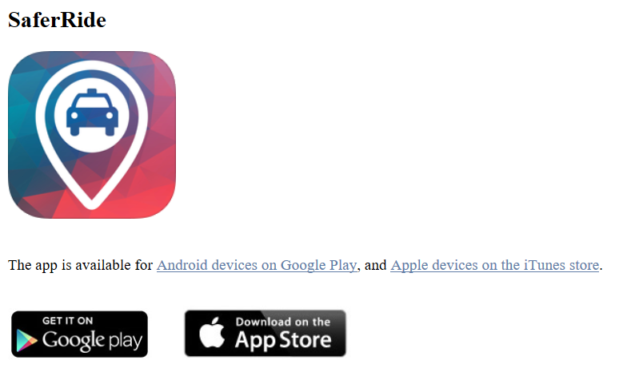

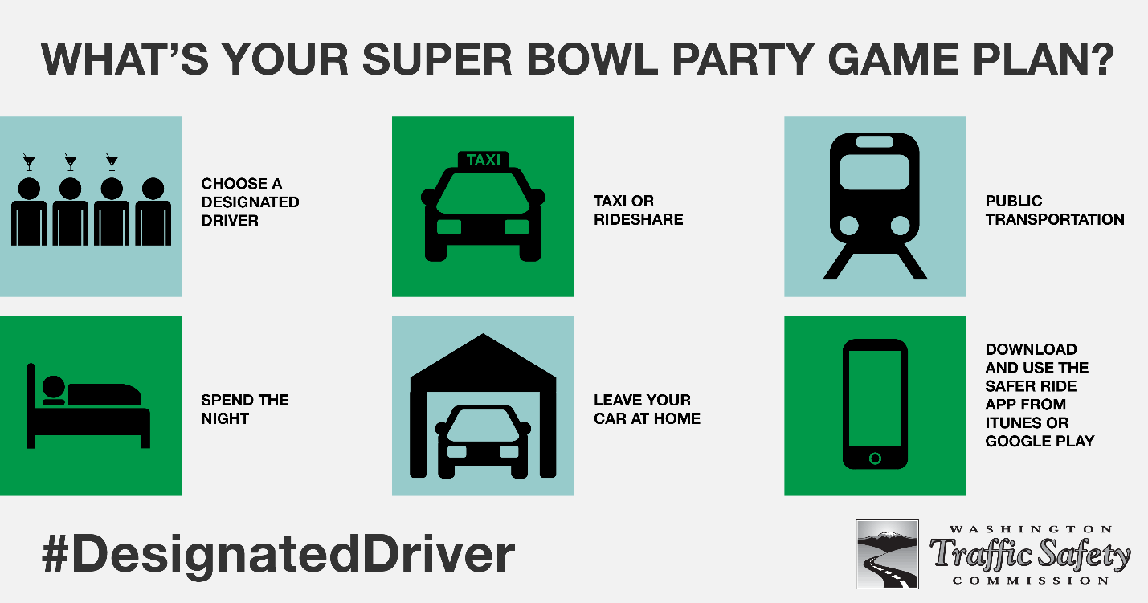

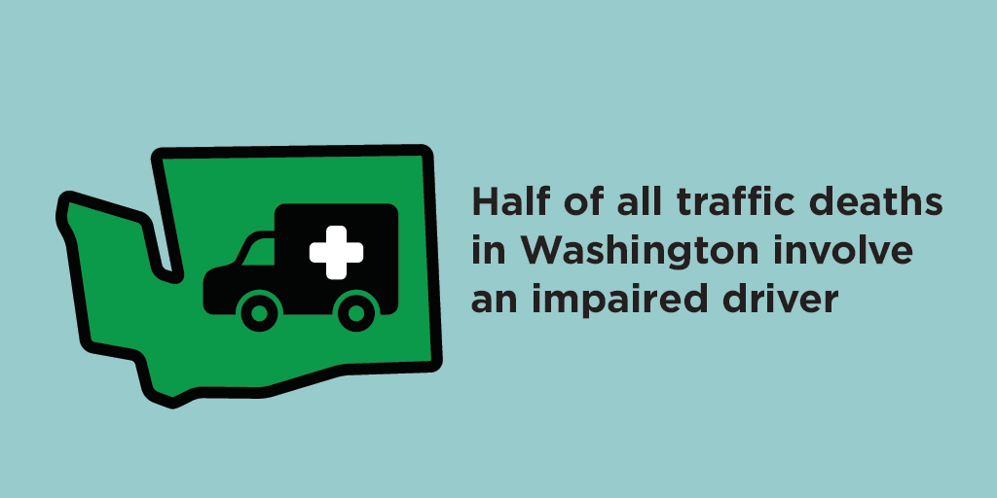

Social Media Posts
Please consider using the following messages and graphics on your Twitter, Facebook and/or Instagram feeds. We’ve offered this sample schedule, which you can program in advance. The URLs direct to www.wedrivetozero.com/dui, except for the post on NHTSA’s “SaferRide” app, which directs to a page where users can download the app.

Post Date | Messages | Graphic
Thursday, Feb 1 | Every #SuperBowl Party and partier must have a game plan to prevent drunk or impaired driving! http://ow.ly/wnWb30i0z1z #DesignatedDriver  Be a team player! Volunteer to be a #DesignatedDriver on #SuperBowl Sunday http://ow.ly/wnWb30i0z1z | 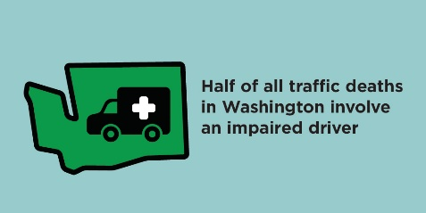  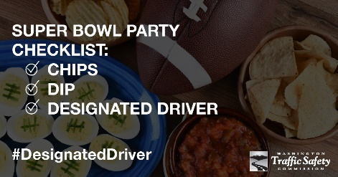
Post Date | Messages | Graphic
Friday, Feb. 2 | Everyone is an MVP on our roads. Make a game plan! #SuperBowl #DesignatedDriver http://ow.ly/wnWb30i0z1z  Hosting a #SuperBowl party? Be a good referee. Make the right call and take their keys before they drink and drive. http://ow.ly/wnWb30i0z1z | 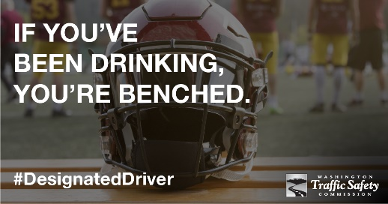  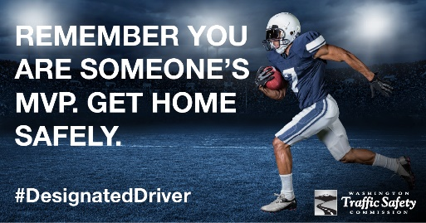
Saturday, Feb. 3 | The teams have a game plan. What’s yours? Know before you party how you will get home safe #DesignatedDriver http://ow.ly/wnWb30i0z1z  When you’re drunk or high, you make bad decisions. Driving impaired is the worst decision. Before you party, make your plan to get home safe. #SuperBowl #DesignatedDriver http://ow.ly/wnWb30i0z1z  Make it easy to get home after the game. Plan for a #DesignatedDriver or use the SaferRide app to get home. http://ow.ly/MyVQ30i1Dra | 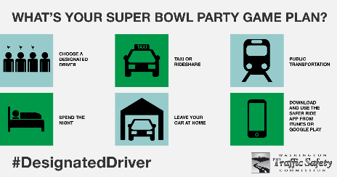  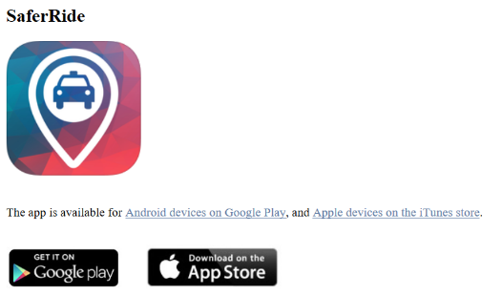  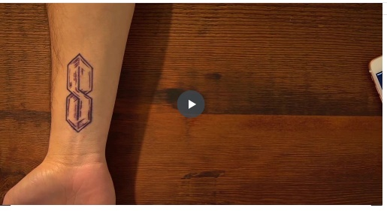  Click image below for video
Super Bowl Sunday | Repeat all messages throughout the day

