When social distancing, bad weather, or other factors make in-person car seat checks impossible, a virtual car seat check is a good alternative. While phone support has always been an option for remote education, smartphones, tablets, and computers make virtual car seat checks with audio and visual components possible through technology such as FaceTime, Skype, Zoom, Google Duo, and others.
Virtual checkups are handy, but have inherent challenges, so care should be taken in planning. Communicate with caregivers to ensure they are clear about the format and expectations. (Find sample emails that can be used as templates at : www.wacarseats.com and www.saferidenews.com)
And, even when a checkup is conducted remotely, it’s important for CPSTs to follow the basic principles of Learn-Practice-Explain, careful documentation, and liability release sign-off.
Learn-Practice-Explain:
A virtual checkup ensures that the caregiver will do all the hands-on work. However, a CPST ought to take steps to make the virtual setting as effective as possible. Consider the following:
- Have props on hand, including sample car seats, dolls, and even access to a vehicle, in order to demonstrate steps on camera.
- Video quality will be important. Plan to use the device option with the largest screen, whenever possible. If you will be demonstrating using props (as recommended), plan to use a desktop/laptop computer, have a stand ready to position a hand-held device, or enlist a helper. Since the caregiver will be working in a vehicle, it is probable that he/she will need to use a hand-held device, so urge them have another adult available to operate the camera.
- Remember that audio quality will also be essential, so ensure that both the CPST and caregiver are in an area with a reliable connection and away from background interference, such as office or street noises.

Document:
A virtual seat check should be documented in the same way that an in-person check is documented. If you don’t already have a supply of documentation forms, contact your state CPS coordinator to get some or consider using the National Digital Car Seat Check Form. Find them using these links:

Find a listing of state CPS coordinators here:
https://www.nhtsa.gov/car-seats-and-booster-seats/training-contacts-state-child-passenger-safety (In Washington state, find a checkup form PDF at https://www.wtscpartners.com/car-seat-technicians.)

National Digital Car Seat Check Form:
https://www.cpsboard.org/resource-center/digital-car-seat-check-form
It’s ideal to have some information well in advance of beginning a car seat check, and this is especially true of a virtual checkup. For instance, knowing details about the child, car seat, and vehicle allows a CPST to prepare by reviewing the owners manuals for the car seat and the car, checking the LATCH Manual, checking for recalls, and gathering the most useful props. A pre-checkup form to collect this information can be found here: www.wacarseats.com and www.saferidenews.com
Liability Release Sign-Off:
Having the caregiver sign a hold-harmless agreement prior to providing education is always recommended, even for a virtual car seat check. This is another reason to use the pre-checkup form mentioned above. In addition to providing basic information, the form allows the caregiver to sign a hold-harmless agreement before the educational interaction. Once the completed and signed form is returned, the scheduled virtual checkup can be conducted.
Send Follow-Up Resources:
Using email (or, if necessary, regular mail), send the caregiver follow-up information. At minimum, let them know how to access CPS resources in the community, including how to find out about future opportunities for an in-person checkup, as needed. Also, send any information that might be needed as a result of the virtual checkup, including answers to lingering questions (or who to ask instead) and links to relevant flyers, FAQs, videos, etc.

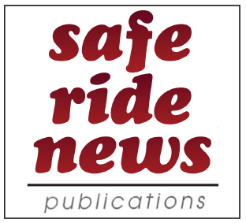
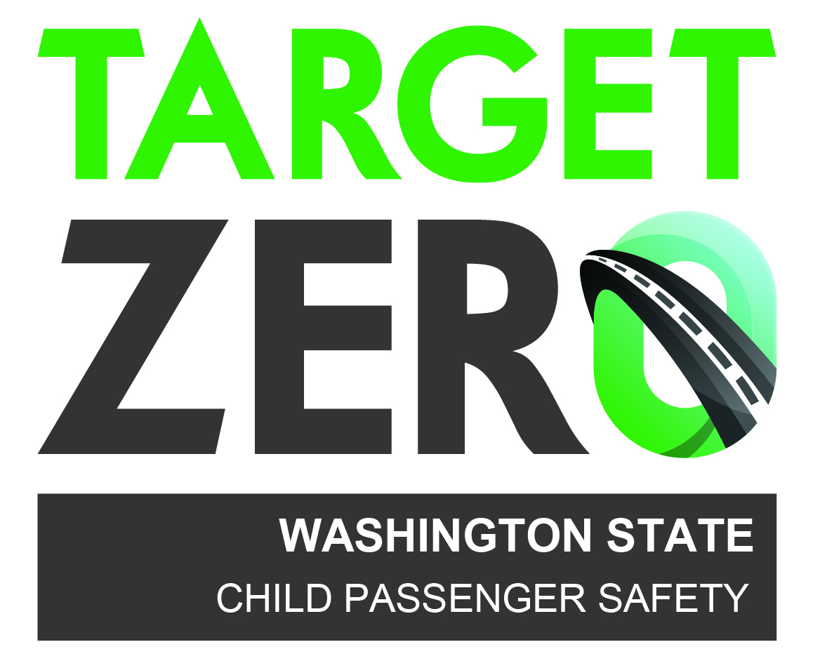
This material was originally developed by Safe Ride News Publications and
Washington State’s Child Passenger Safety Program, and happily shared with
our partners in the child passenger safety community.

