Pedestrian Safety Fact Sheet --Taking Steps for Safety

Washingtonians Walk

- Nearly all Washingtonians walk on a daily basis. Between 25% – 30% of the state’s population do not drive and walking is their means of transportation.

- Walking safely seems simple, but pedestrian traffic deaths are on the rise nationally and in Washington.

- Distraction, speed, impairment and visibility are all factors in pedestrian deaths.

- We can all take steps to improve pedestrian safety, when we walk and drive. When driving, slow down and pay extra attention at intersections and crosswalks. When walking, make eye contact with drivers and don’t enter the crosswalk until cars have totally stopped moving.

Pedestrian Safety by the Numbers
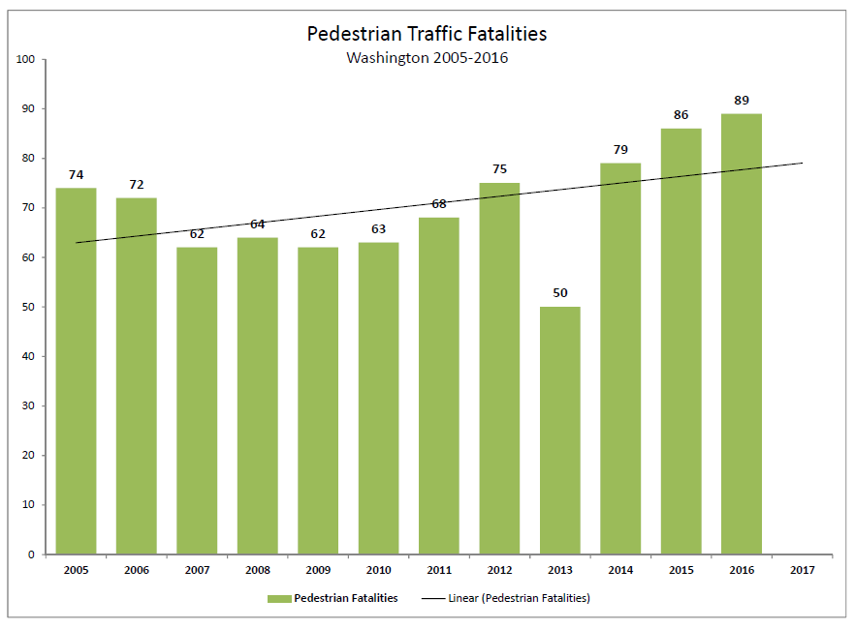
- Pedestrians accounted for 15.6% of traffic fatalities between 2012 and 2016 in Washington, and 14.9% of serious injuries.

- There were 89 pedestrian fatalities in Washington in 2016, and pedestrian fatalities have been increasing.

- Young children and the elderly are more likely than others to be killed or injured in a pedestrian collision. Nationally, 22% of children age 10-14 who were killed in a traffic crash were pedestrians.

- Distraction kills pedestrians too – 32% of Washington pedestrian traffic deaths involved a distracted driver.

- Impairment isn’t just deadly behind the wheel – 43% of Washington pedestrian deaths involved an impaired pedestrian.

Take Steps for Pedestrian Safety

- Cross streets at marked crosswalks or intersections. 72% of pedestrian fatalities occurred at non-intersections.

- Bring back the buddy system – help a buddy who can’t walk safely.

- See and be seen – drivers need to see you to avoid you. Use the crosswalk, make eye contact, wear bright or reflective clothing and use a light at night.

- “Plan before you party” works for pedestrians too. If you plan to party, plan to find a ride with a sober driver, spend the night, take a taxi, don’t walk drunk or high. Better to crash on the couch than crash in a crosswalk.

Take Steps for School Children Safety

- If your child walks to school or to the bus stop, make sure they are wearing bright or reflective clothing. Teach them to look both ways when crossing the street and to always use a crosswalk.

- The best teacher is your behavior – show them how to walk safely.

- Support or encourage activities at your child’s school, such as Feet First’s “Safe Routes to School” program.

  - Feet First partners with schools to organize walking school buses and walk-to-school celebrations, provide training and technical expertise, create safety curricula and support existing programs across Washington.

Drive Safe for Pedestrians

- Stop and yield for pedestrians in intersections and crosswalks, always. It’s the law.

- Park responsibly – don’t block a sidewalk or crosswalk.

- Be a pedestrian – if you can walk instead of drive, do it!
###

