In light of the current necessity for social-distancing precautions, CPSTs are asked to cancel scheduled checkup events and high-volume inspection stations until further notice. In lieu of these services, you are encouraged to shift outreach to remote/virtual education and low-risk by-appointment checkups. See the following for further recommendations.

Before conducting in-person appointments:
Prior to agreeing to schedule an in-person appointment, ask the caregiver AND yourself:
- Have you or a close family member been outside of the USA in the last month?
- Are you or any family member experiencing a fever? Cough? Shortness of breath?
If YES to either question, do not meet in person with this family.
- Offer remote services, if you are comfortable with that. Virtual seat-check documents for conducting remote assistance are being developed; look for future announcements.
If NO to both questions, continue with scheduling services.
- Let them know that you will be providing education and guiding them through the process. Their participation will be hands on, and they will be asked to follow your verbal guidance (to respect social distancing).

While conducting in-person car seat checks:
- Check to ensure that the answers to the health questions (above) have not changed.
- Refrain from touching any surfaces as you instruct the caregiver to do all necessary adjustments and installation. (Working alongside them using a sample car seat of your own may help facilitate the process.)
- Wash hands thoroughly between each appointment and/or use hand sanitizer with at least 60% alcohol.
- If you come across an unsafe car seat, have the family disassemble and properly dispose of it.

Copy/paste the following information into online interactions with caregivers:
- Read and follow your car seat instructions. If you have misplaced your instructions, you should order a new set by contacting the manufacturer. Also, you can use the car seat model name/number/date to download instructions on the manufacturer’s website.
- Read and follow your vehicle instructions. Be sure you know where in the back seat a car seat may be installed. Many vehicles don’t allow use of the lower anchors in the center of the back seat, so you may need to use a seat belt if installing there.
- Watch online usage videos. These videos walk you through proper installation and/or how to harness your child. Watch videos after reading your car seat and vehicle instructions. The most reliable videos about specific car seat models are ones accessed from the manufacturer’s website. General car seat installation videos may also be helpful: https://www.nhtsa.gov/equipment/car-seats-and-booster-seats#install-instructions
- Call, email or FaceTime! Contact your local car seat inspection services and see what assistance they can provide by remote access.

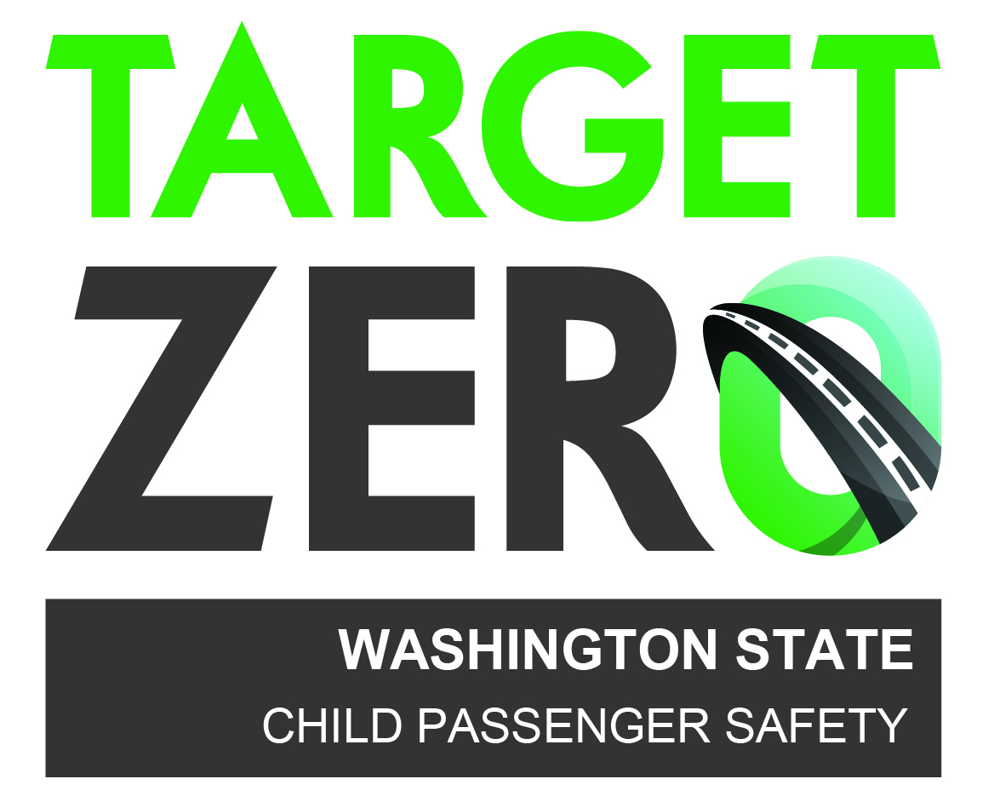
This material was originally developed by Safe Ride News Publications and
Washington State’s Child Passenger Safety Program, and happily shared with
our partners in the child passenger safety community.

