Motorcycle Fatalities Increase in Washington
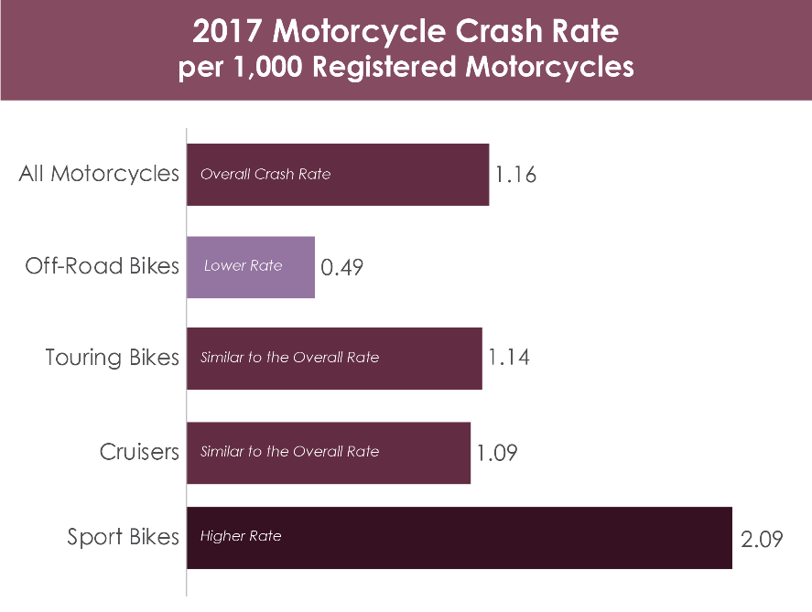
- Due to the stay at home culture around the COVID-19 virus, there are fewer vehicles on the roads, and overall traffic fatalities are down. But we are witnessing an alarming increase in deadly motorcycle crashes early this year.

- Our state has had an increase in deadly motorcycle crashes over the last six weeks. There were 12 just in April. So over half of the statewide traffic deaths in April were motorcycle riders. We haven’t seen this many April motorcycle fatalities since 2006.

- Motorcycles are only 3% of all registered vehicles in Washington. And on average, they make up less than 20% of our traffic fatalities each year. But in April, motorcycle fatalities were 53% of our total traffic fatalities. We haven’t seen this many motorcycle rider deaths in the month of April since 2006.

- In early May, eight motorcycle riders died in crashes in one week (May 3-10) for a total of 24 motorcycle fatalities this year in Washington.

- July, August, and September are when we usually see more motorcycle crashes in Washington. So it’s disturbing that so many motorcycle riders are dying in crashes in April and May this year.
Crash Fault or Causation Factors:
- These crashes are preventable and unacceptable. The MISPERCEPTION from some riders is that these crashes are caused by another car driver. The fact is that 70% of fatal crashes last year were caused by the rider.

- Washington State Patrol (WSP) is reporting an increase in the number of riders who are traveling at over 100 miles per hour. WSP is also reporting an increase in the number of riders failing to stop for law enforcement (eluding police) the past couple months.

- In 2020, officer reports show that 18 of the 24 motorcycle fatalities were caused by the rider’s behaviors or actions. Six of the 24 fatalities in 2020 involved another vehicle interfering with the rider’s path of travel.

- Only one crash involved an impaired rider. But SPEEDING, loss of control in corners and curves, following too close, and failure to yield are the main contributing factors.

- We know that people have more free time to ride, gas prices are low, and there are fewer cars on the roads resulting in less congestion. This allows an opportunity for more space and increased speeds.

- Motorcycles are vulnerable road users. Riders must create their own safety. This includes wearing helmets and other personal protective gear. Always ride sober, slow down, be aware of your surroundings, and get training to have the skills to help keep you safe.

- And with more motorcycles on our roads, drivers should watch out for motorcycles. Drivers should leave space around motorcycles. And do all you can to protect yourself by driving sober, wearing a seatbelt, and watching your speed. A collision with a motorcycle can still cause serious injury and death to the car or truck driver.

- Even though there is less traffic on the roads, please don’t take unnecessary risks while driving. We need to work together to protect our community in these unprecedented times.

###

