OCTOBER 2020 CAMPAIGN
“PEDESTRIAN SAFETY”

SAMPLE EMAIL AND WEBSITE MESSAGES

The following are suggested messages that you can tailor to emails messages or post on your website:

MESSAGE 1:
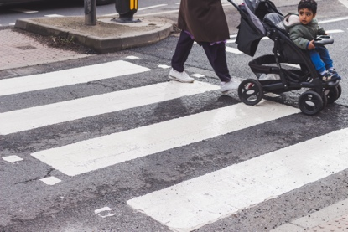
We can all take steps to improve pedestrian safety when we walk and drive. When driving, slow down and pay extra attention at intersections and crosswalks. When walking, make eye contact with drivers and don’t enter the crosswalk until cars have stopped moving.

MESSAGE 2:

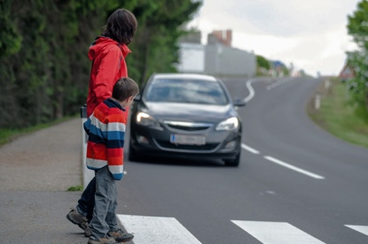
Dark, rainy days make it harder for cars and walkers to see each other. Many thanks to drivers who give walkers the right-of-way and keep their speed down when visibility diminishes.

