NOVEMBER 2020 CAMPAIGN

FACT SHEET

Seat Belt Use in Washington

Most Washingtonians wear their seat belt, with the state’s seat belt use rates at 93.2 percent, one of the highest in the nation.

- Eight counties have better rates than the state rate (Benton, Chelan, Clark, Cowlitz, Grant, King, Kittitas, Lewis).
- Three counties have lower seat belt use rates than the state rate (Kitsap, Pierce, and Thurston).
- The other 13 counties had similar rates as the state.

Percent of All Fatal and Serious Injury Crashes
That Were Unrestrained-Related, by County
2015–2017 (targetzero.com)

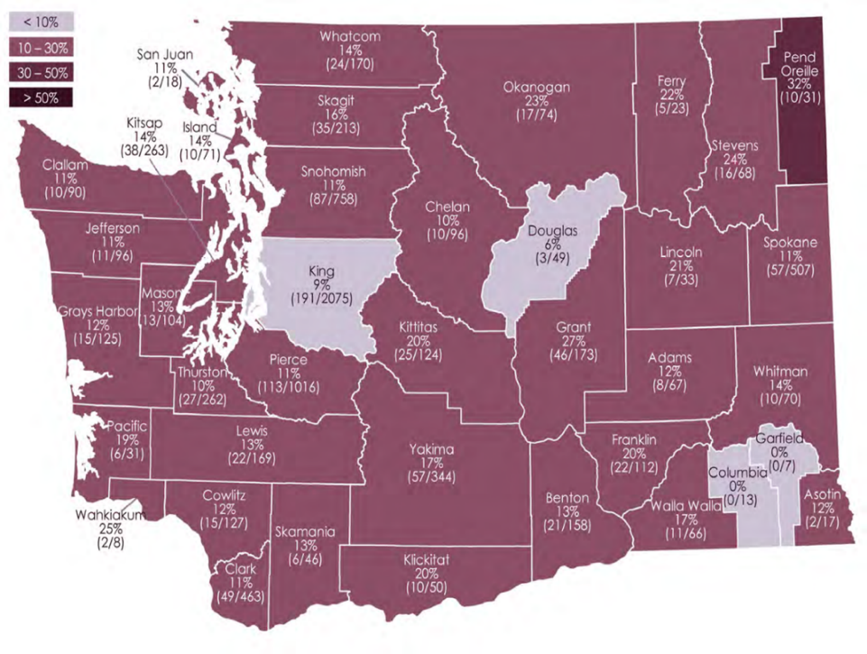

Despite Washington’s high seat belt use rate, people still die on Washington roads who were not buckled up. In 2019:

- More than 20% of road deaths in Washington involved people not wearing a seat belt: 106 people out of 524.
- 81% were the drivers.
- 69% were male.
- The most frequent age range of unrestrained drivers is 21-to-25-years-old, followed by 36-40-years-old.

Buckle-up to Save Lives

- Seat belts save lives. Your chance of surviving a crash increase by 45% if you are wearing your belt.

- According to the 2019 Target Zero plan, “much of the success in reducing traffic fatalities and serious injuries has occurred because of vehicle design and seat belt use.”

- Nationally, seat belts saved an estimated 14,955 lives in 2017, according to the National Highway Traffic Safety Administration.

De-Bunking a False Sense of Security

It’s easy to buy-in to common misperceptions of security (statistics below are national):

- Big vs. Small: If you’re not buckled, being in a pickup or other large vehicle isn’t safer. In fact, 61 percent of pickup truck occupants who were killed in 2016 were not buckled up. That’s compared to 42 percent of passenger car occupants who were not wearing seat belts when they were killed. Big truck or small car, seat belts are the safest bet.

- Front Seat vs. Back Seat: Too many people wrongly believe they are safe in the back seat unrestrained. Forty-seven percent of all front-seat passenger vehicle occupants killed in crashes in 2016 were unrestrained, but 57 percent of those killed in back seats were unrestrained. If you’re in the back, buckle-up.

- Rural Road vs. City Street: People who live in rural areas might believe that their crash exposure is lower, but in the U.S. in 2016, there were 13,732 passenger vehicle fatalities in rural locations, compared to 9,366 fatalities in urban locations. Out of those fatalities, 49 percent of those killed in the rural locations were not wearing their seat belts, compared to 46 percent in urban locations. Whether on busy city streets or a dusty rural road, buckle up to stay safe.

###

