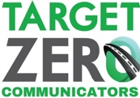

NOVEMBER 2020 CAMPAIGN

KEY MESSAGES

Seat Belts Save Lives

Safety matters to Washingtonians. We practice physical distancing, wearing masks, and washing our hands. And most of us – 93 percent – wear our seat belts because safety matters to us.

- Wearing your seat belt drops your risk of fatal injury in a crash by 45%. There is no substitute.

- You can help save a life today by getting all of Washington to wear their seat belts:
  - Model: Always wear your seat belt
  - Discuss: Speak with family members, especially young drivers, about the importance of seat belt use.
  - Advocate: Say something when you see someone not wearing their seat belt

- Front seat or back seat, city roads or country roads, big trucks or small cars, it’s the same: Seat belts save lives.

# # #

