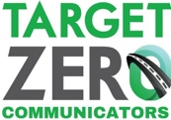

NOVEMBER 2020 CAMPAIGN
SAMPLE SOCIAL MEDIA MESSAGES/GRAPHICS

Here are sample graphics and related content that we encourage you to use on your organization’s social media. Feel free to adapt for use on your website or customized emails too.

MESSAGE | GRAPHIC
Wearing your seat belt drops your risk of fatal injury in a crash by 45%. Get home: No ruby slippers required – just your seat belt! | 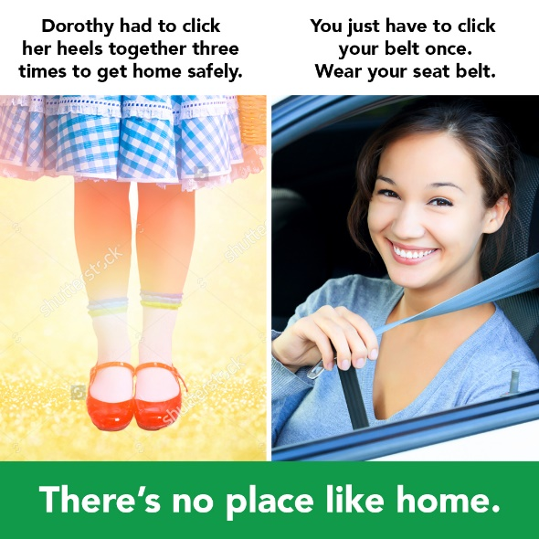
Wearing your seat belt drops your risk of fatal injury in a crash by 45%. There is no substitute. | 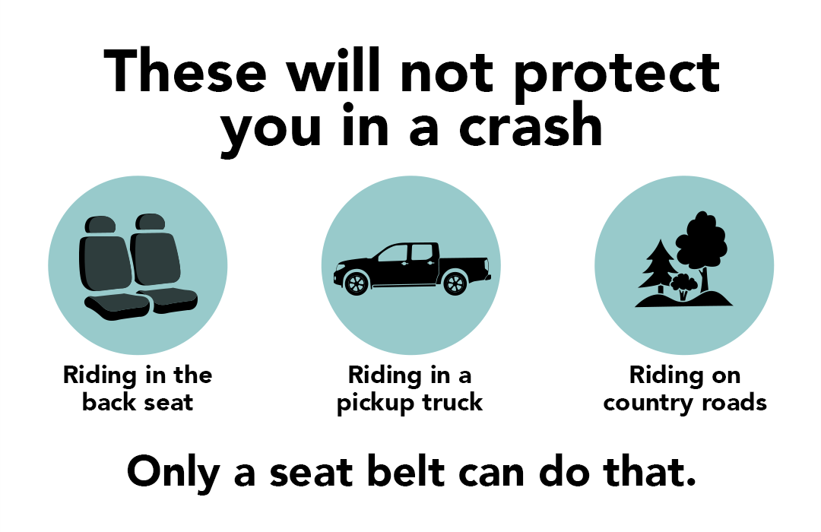
There’s always something more we can do to save lives by getting people to buckle up! | 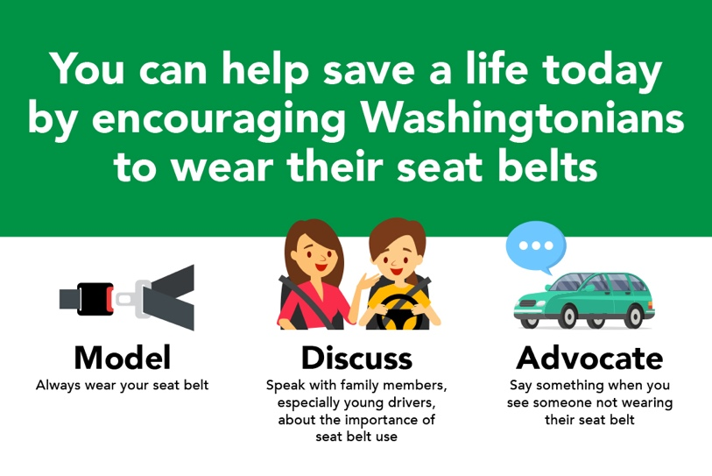
Safety is appealing. | 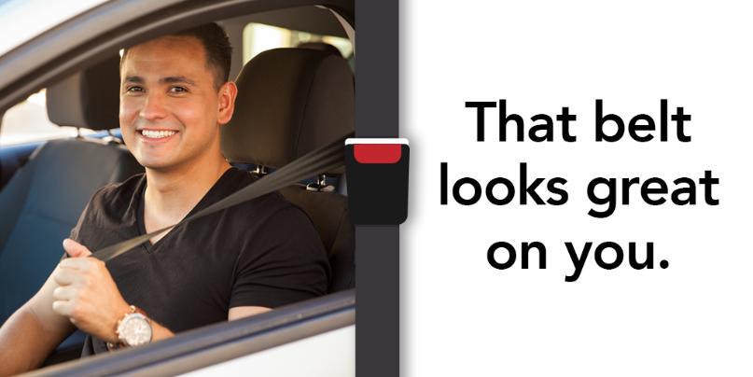
Safety is appealing. | 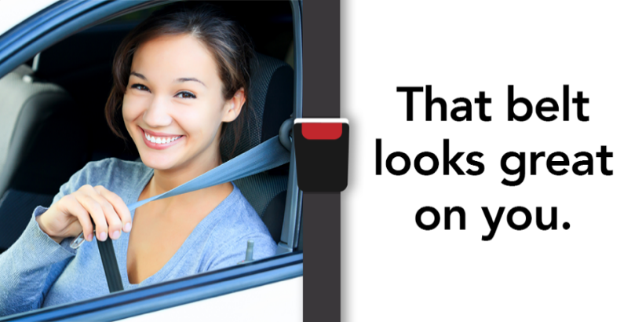
Llénelo. Póngase el cinturón. | 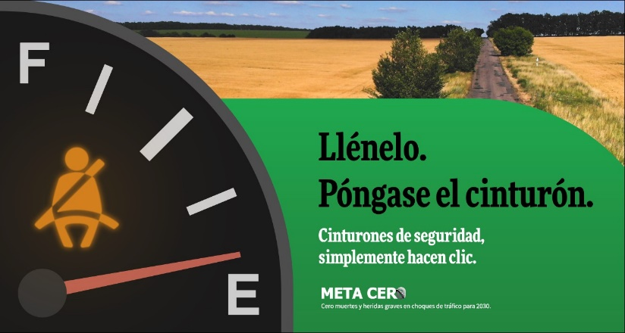
Not wearing a seat belt? Now that’s just scary. Buckle Up.  Video | 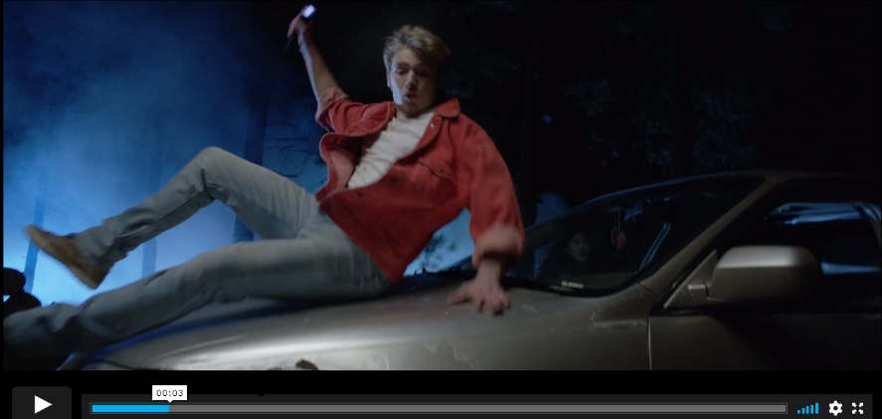
Setting an example: I feel safer when I’m buckled up and when she’s buckled up.  Video | 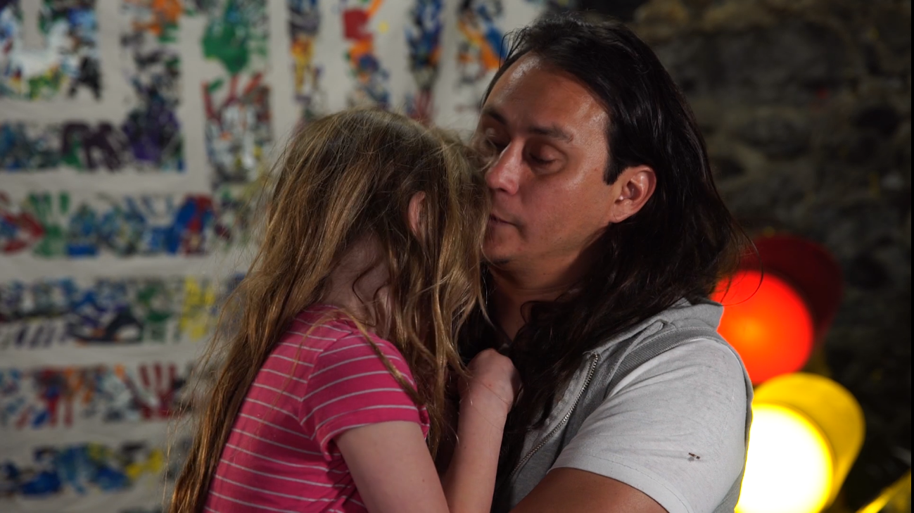
“I know the importance of wearing a seat belt.” Tina, a health care worker and a mom, speaks out.  Video | 