OCTOBER 2020 CAMPAIGN

“PEDESTRIAN SAFETY”
SAMPLE SOCIAL MEDIA MESSAGES/GRAPHICS

The following are sample graphics and related content that we encourage you to use on your organization’s social media. Feel free to adapt for use on your website or customized emails too.

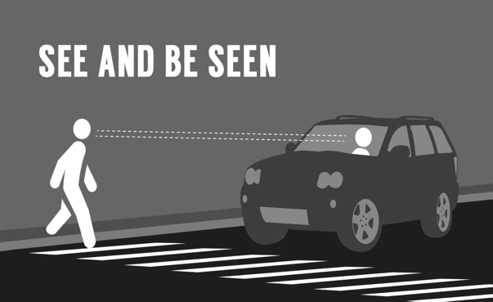  Take steps for safety -- give pedestrians the right of way and slow down at night. |  | 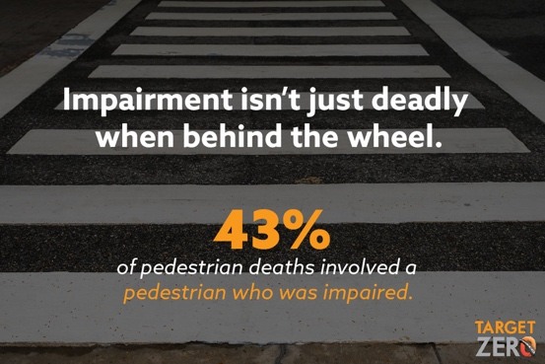  Four in ten pedestrian deaths involve an impaired pedestrian. “Plan before you party” works for walking, too. If you plan to party, plan for a sober ride afterwards.
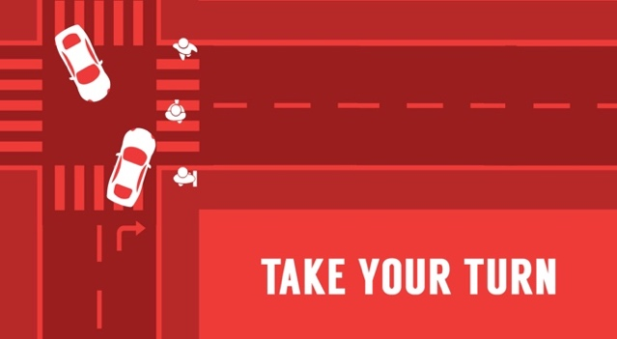  Take Your Turn: Take steps for pedestrian safety. |  | 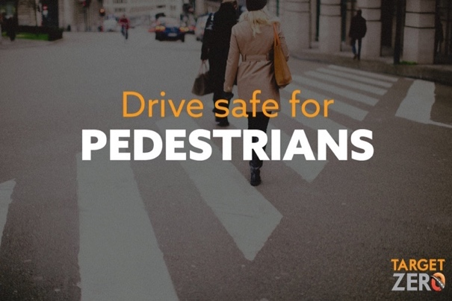  Drive safe for pedestrians. Stop for pedestrians in intersections and crosswalks.
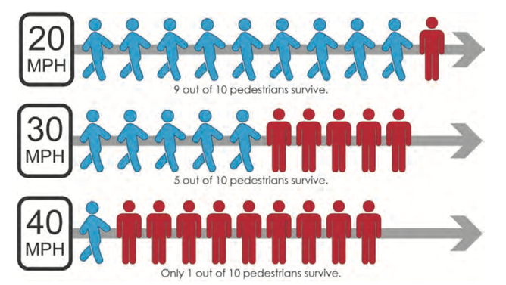  A person driving over 25 mph is less able to see and respond to other road users, which increases the likelihood of a crash. |  | 