SEPTEMBER 2020 CAMPAIGN
“TEEN DRIVING”

SAMPLE SOCIAL MEDIA MESSAGES/GRAPHICS
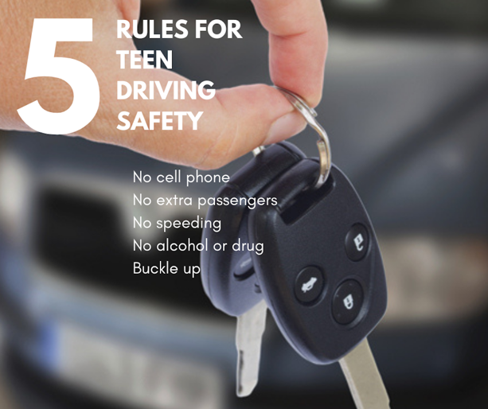  More than 100 young people die on Washington roads each year, and it’s completely preventable. As parents, you can be a good role model for teaching your teen safe driving behavior.  https://wadrivetozero.com/young-drivers/ | 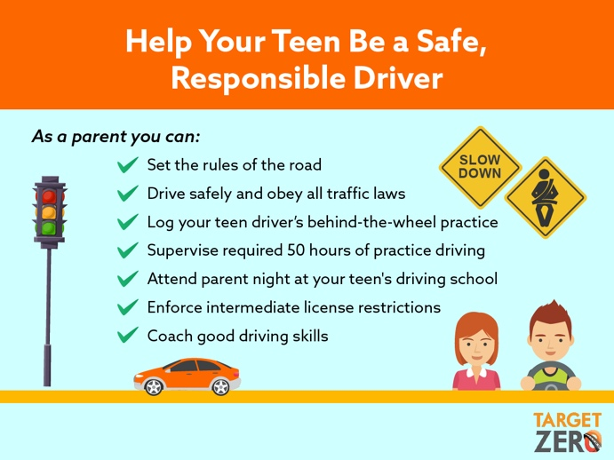  Teen drivers look to you as parents to help them be safe when they get behind the wheel. Be a role model and a coach for your child.  https://wadrivetozero.com/young-drivers/
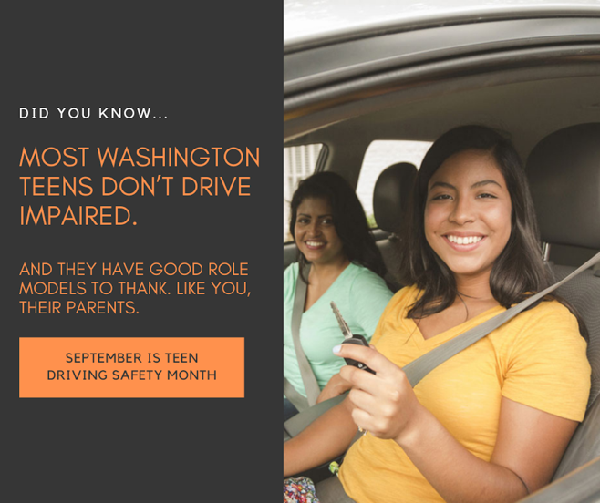Motor vehicle crashes are the leading cause of unintentional death for young people ages 16-25 in Washington.
https://wtsc.wa.gov/programs-priorities/young-drivers/

