2020 “Step In” Impaired Driver Campaign
Social Media Graphics
Please download and use these social media graphics that you can incorporate into your social media. First responders from around the state have provided videos about how impaired driving has affected their lives and how they “Step In” with their own friends or families. You can download those videos and use on Facebook or Twitter, as demonstrated in the first message.
We encourage you to share these messages now through New Year’s Day.

Washington’s First Responders Step In to share their stories and advice for preventing impaired driving #StepIn #TargetZero | 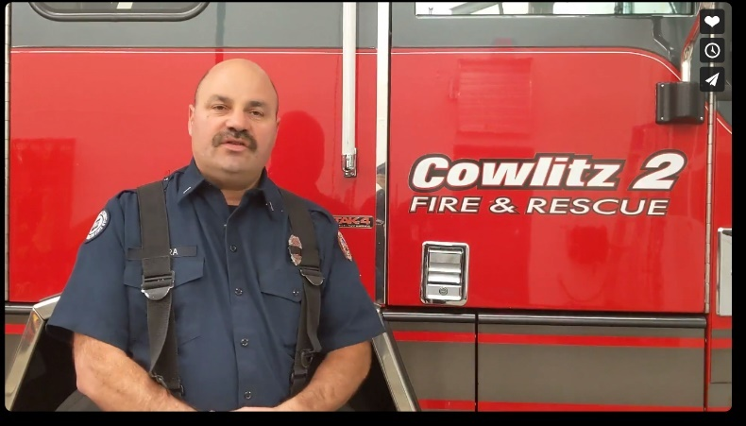  Download additional videos here to use with this social media post.
Stepping in to tell a friend to crash on your couch may be the greatest gift you can give. Step In to prevent impaired driving. #StepIn #TargetZero
Most people in Washington will step in to prevent someone from driving impaired. Be a hero. Step In. Prevent impaired driving. #StepIn #TargetZero | 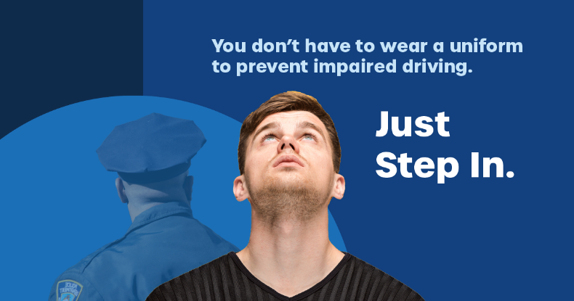
Let’s give our first responders a break this holiday. Step In to prevent impaired driving. #StepIn #TargetZero
Everyone can prevent impaired driving. Most people in Washington (81%) will intervene to prevent impaired driving when they can. Take action. #StepIn #TargetZero | 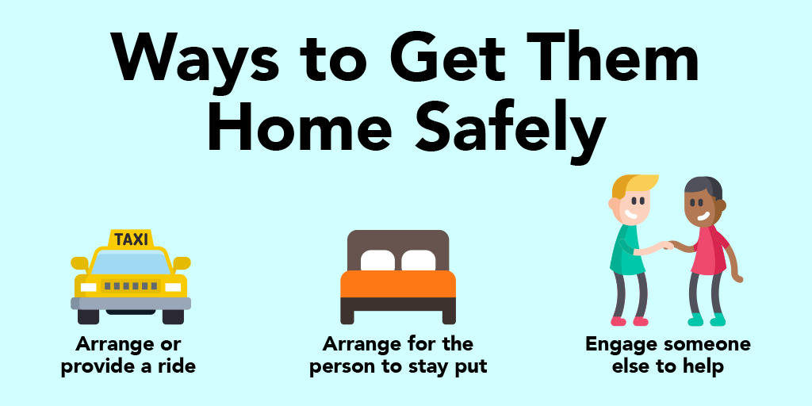
Stepping In is simple:  - Arrange or provide a ride  - Offer your couch for the night  - Arrange for your friend or loved one to stay where they are  - Engage someone else to help, including calling 911 | 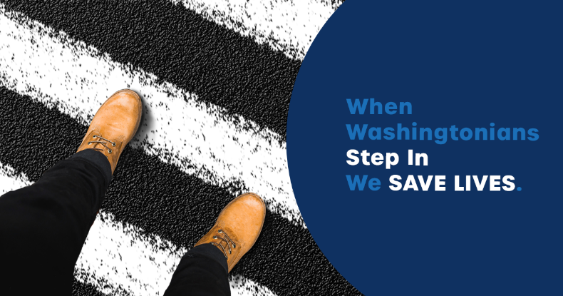
Stepping In is simple:  - Arrange or provide a ride  - Offer your couch for the night  - Arrange for your friend or loved one to stay where they are  - Engage someone else to help, including calling 911 | 