2021 Super Bowl “Make a Game Plan” Impaired Driver Campaign
Social Media Graphics
Please download and use these social media graphics that you can incorporate into your social media.
Some things shouldn’t be left to chance. Have a game plan for after the Super Bowl, so everyone has a safe ride home. #SuperBowl | 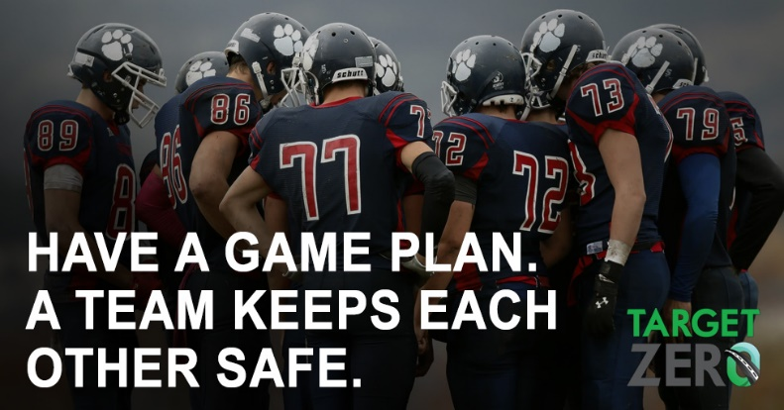
We can all keep our roadways safe if we intervene to stop our friends from driving impaired. Make the call – get a taxi, a rideshare or a designated driver. #SuperBowl | 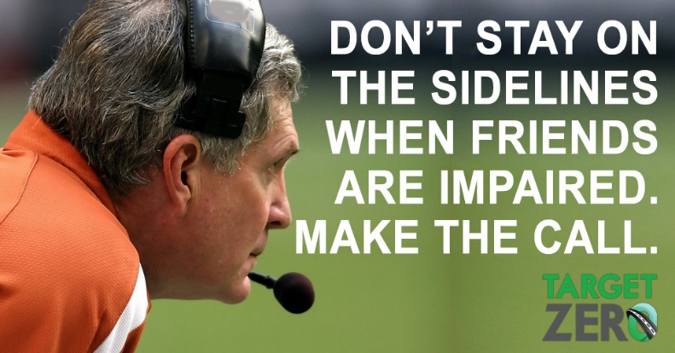
Everyone can prevent impaired driving. Most Washingtonians (81%) will intervene to prevent impaired driving when they can. Take action. #SuperBowl | 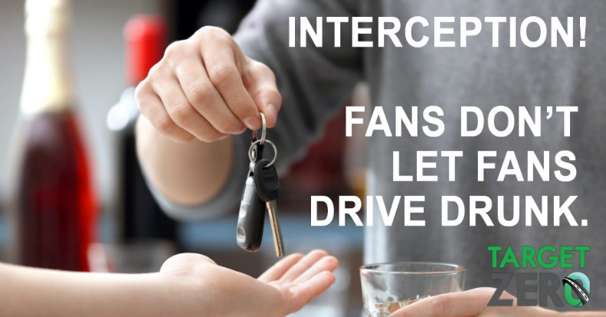
When the game is over, make the right call. Get everyone home safely in a cab, a rideshare or with a sober designated driver. #SuperBowl | 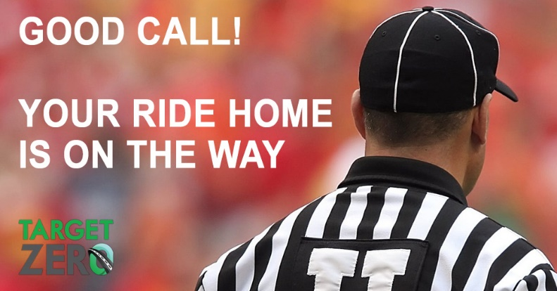
Have a Game Plan for Super Bowl Sunday so everyone gets home safe. #SuperBowl | 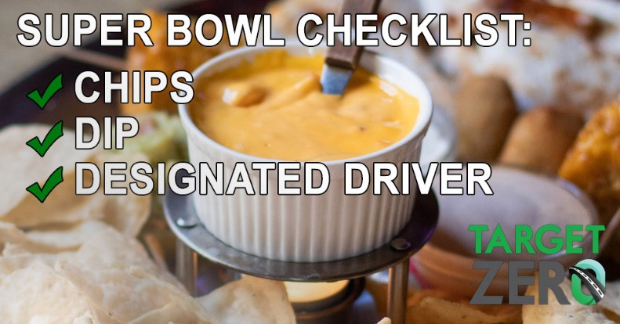
A good coach knows when to put in a substitute. A designated driver is a great team player. #SuperBowl | 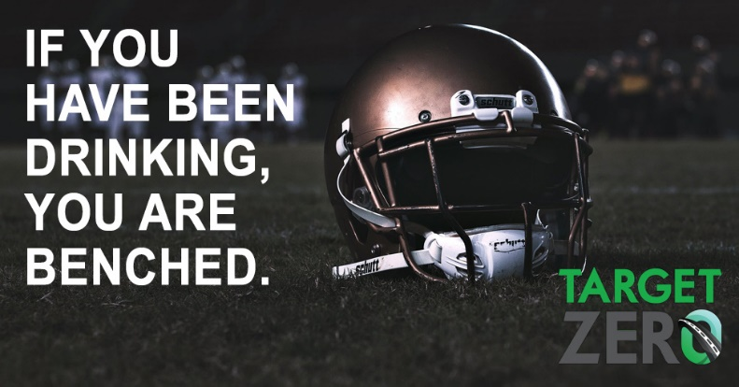
Enjoy the Super Bowl, but make sure you plan to get home safely after the game. #SuperBowl | 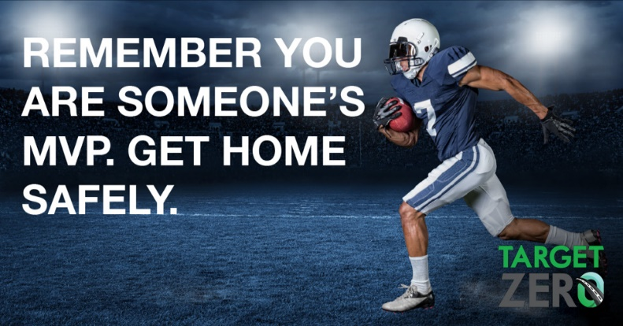
Everyone can prevent impaired driving. Most Washingtonians (81%) will intervene to prevent impaired driving when they can. Take action. #SuperBowl | 