2021 St. Patrick’s Day Impaired Driver Campaign
Sample Social Media Posts
Sample messages (with our graphics included) that you can us in your social media.
Sleeping on a friend’s couch is a better choice than driving impaired.  #SaintPatricksDay  http://ow.ly/fkrB50DRlLd | 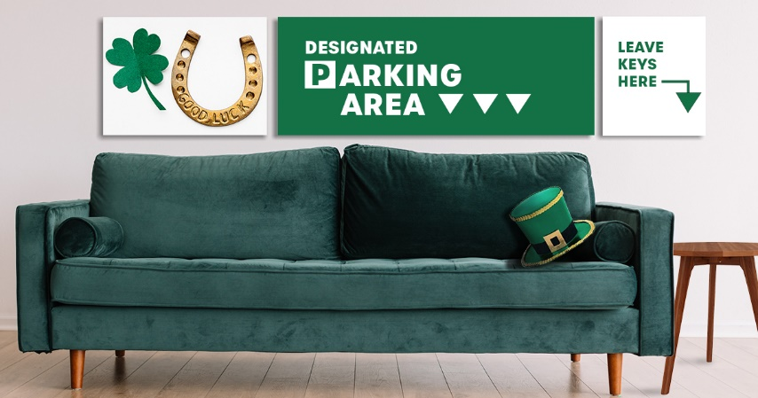
There are sober options to get you there safely.  http://ow.ly/fkrB50DRlLd#SaintPatricksDay | 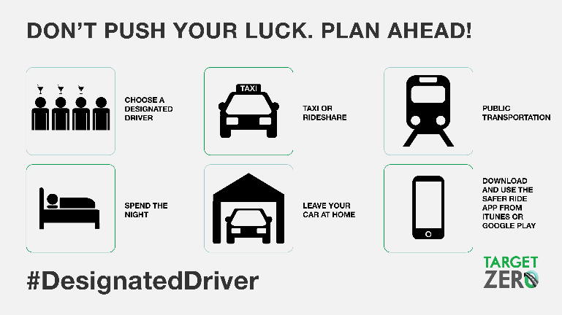
The rideshare app can give you safe options to get home safely if you’re partying on #SaintPatricksDay.  http://ow.ly/fkrB50DRlLd | 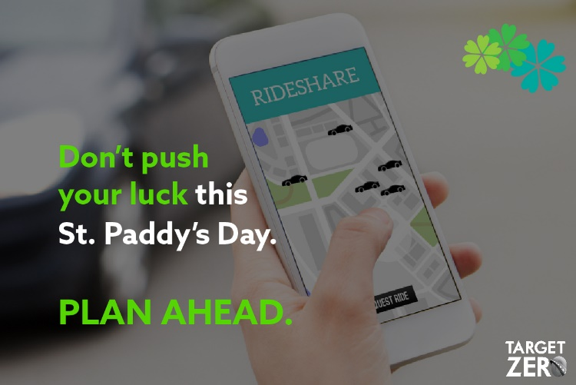
#SaintPatricksDay is one of the deadliest holidays on our nation’s roads. If you party, plan ahead. http://ow.ly/fkrB50DRlLd | 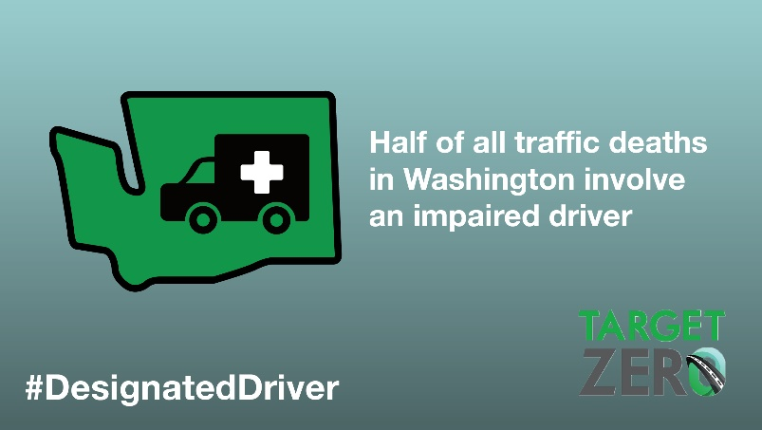
Don’t get pinched this #SaintPatricksDay. If you imbibe, get a ride. http://ow.ly/fkrB50DRlLd | 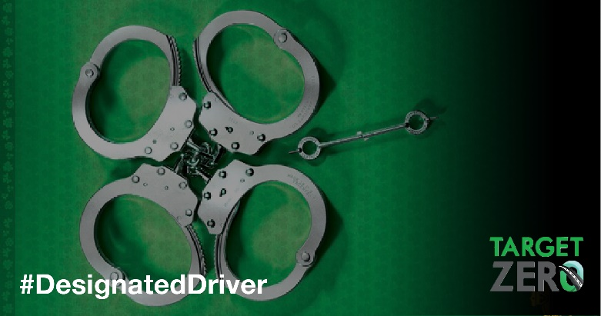

These materials include links to https://wadrivetozero.com/dui for further information and resources and we encourage you to send your key audiences there.

