St. Patrick's Day Impaired Driving Campaign 2021
Overview
No one has to rely on “luck” when it comes to getting home safely – a message we want to share with anyone planning to celebrate St. Patrick’s Day.

Nationally we know that St. Patrick’s Day can be a particularly deadly time on our roads. This year there may even be more revelers on the road, with bars and restaurants beginning to re-open and more people wanting to emerge from their stay-at-home environments.

Help us share the message that there are sober alternatives to driving impaired. We can make those choices for ourselves, or step in to help keep friends and family safe.

To help you share that message, we’ve prepared a communications tool kit for your convenience. This includes:
- Impaired Driving Fact Sheet
- Key messages
- Sample email/website message
- Sample social media messages and graphics

St. Patrick's Day Impaired Driving Campaign 2021
Fact Sheet
St. Patrick’s Day A Cause for Concern
- According to the National Highway Traffic Safety Administration, 280 people in the U.S. lost their lives in traffic crashes involving a drunk driver during St. Patrick’s Day weekend from 2015-2019.
- In 2019 alone, 57 people were killed in drunk driving crashes over the St. Patrick’s Day period.
- During the St. Patrick’s Day holiday reporting weekend in 2020 (March 13-18), 5 people were killed and 21 seriously injured on Washington roadways. One death and three of these injuries involved an impaired driver.

Most of Us Chose Sober Options
- Most of us in Washington (78 percent) don’t drive after drinking; still Washington experienced 231 deaths related to impaired driving in 2019 our state.
- It’s going to take all of us to drive that number toward zero. And that’s exactly what’s happening. Most Washingtonians (81 percent), when in a situation to intervene, take action to prevent someone from driving impaired.
Using Alcohol and Cannabis Together Lead to Crashes
- Driver impairment from more than one substance – usually alcohol and cannabis – is the most common factor in deadly crashes.
- More than half of the drivers in fatal crashes who tested positive for cannabis were also positive for alcohol.
- By 2016, the number of drivers testing positive for impairment from two or more substances became the most prevalent type of impaired driver.
- If you use marijuana after drinking alcohol, you increase your crash risk.
###

2021 St. Patrick’s Day Impaired Driver Campaign
Key Messages
Please incorporate these messages in your communications to your audience over the next few days
Make Your Own Luck St. Patrick’s Day. Work Together to Save Lives
- We all play a role in keeping everyone safe on the road.

- Together we can save lives – alcohol impaired fatal crashes in the U.S. have gone down since the 1982. Still, too many drivers, impaired from alcohol or drugs, or a combination or both, get behind the wheel and drive. We can work together to change that.

- Be someone’s lucky charm this Saint Patrick’s Day. Take one of these actions to prevent someone from driving impaired:
- Arrange or provide a ride
- Offer your couch for the night
- Arrange for your friend of loved one to stay where they are
- Engage someone else to help, including calling 911

- It’s not true that using cannabis after drinking will sober you up. If you use marijuana after drinking alcohol you increase your crash risk.

- You’ll lose a lot of green when you drink and drive. Expect to pay at least $10,000 in attorney’s fees, fines, court costs, lost time at work, higher insurance rates, car towing and repairs, and more if you get a DUI.
###

2021 St. Patrick’s Day Impaired Driver Campaign
Sample Messages
Email/Website message: A sample message you can send to your constituency or post on your website:
Subject: Help Someone get there safely this St. Patrick’s Day
You can make your own luck to get home safely from St. Patrick’s Day festivities. Lucky leprechauns make a plan! Everyone is Irish on Saint Patrick’s Day, and everyone should work together to make our roads safe! No four-leaf clover is going to protect you if you drive drunk or high. But a designated o’ driver will!
Together we get there this St. Patrick’s Day if we choose to be safe:
- Use a taxi or rideshare
- Take public transportation
- Spend the night
- Leave your car at home
- Download and use the Safer Ride app to your phone (download for Android or Apple), which can help get you home safely.
- Step in to prevent someone else from driving impaired
For more information go to https://wadrivetozero.com/dui

###

2021 St. Patrick’s Day Impaired Driver Campaign
Sample Social Media Posts
Sample messages (with our graphics included) that you can us in your social media.
Sleeping on a friend’s couch is a better choice than driving impaired.
#SaintPatricksDay
http://ow.ly/fkrB50DRlLd
There are sober options to get you there safely.  http://ow.ly/fkrB50DRlLd#SaintPatricksDay | 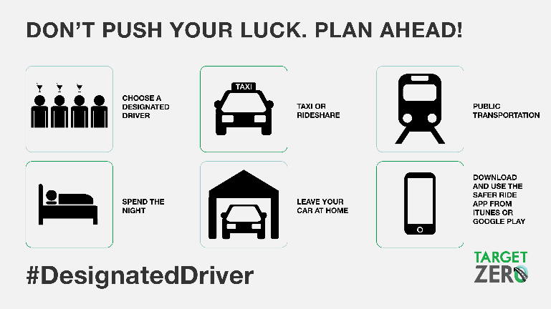
The rideshare app can give you safe options to get home safely if you’re partying on #SaintPatricksDay.  http://ow.ly/fkrB50DRlLd | 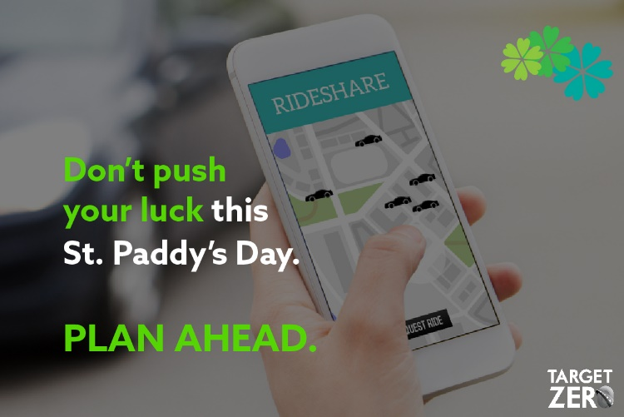
#SaintPatricksDay is one of the deadliest holidays on our nation’s roads. If you party, plan ahead. http://ow.ly/fkrB50DRlLd | 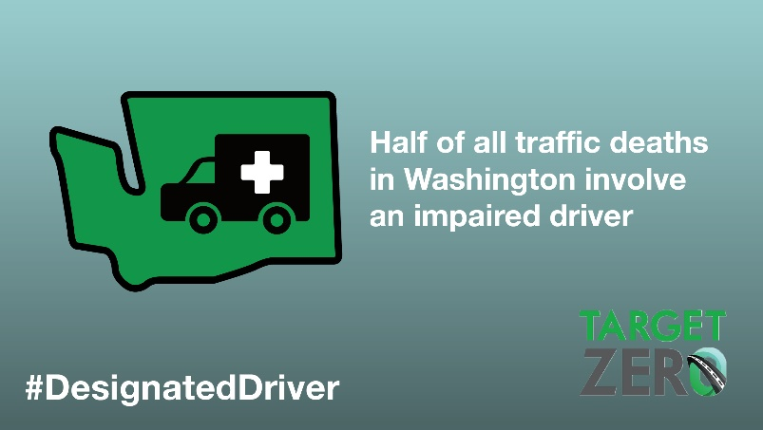
Don’t get pinched this #SaintPatricksDay. If you imbibe, get a ride. http://ow.ly/fkrB50DRlLd | 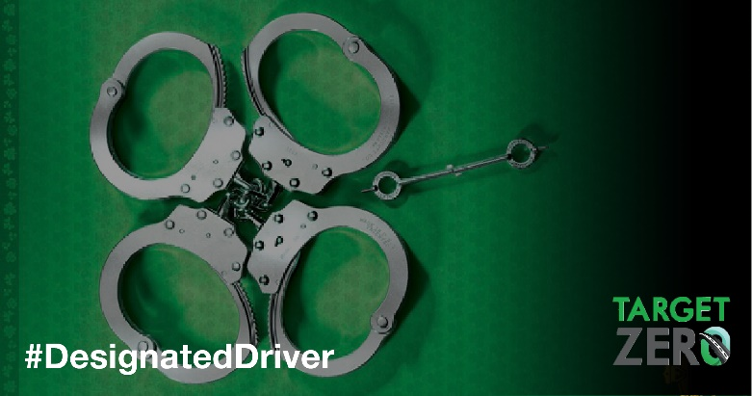

These materials include links to https://wadrivetozero.com/dui for further information and resources and we encourage you to send your key audiences there.

