2021 Seat Belt Campaign

FACT SHEET

Seat Belt Use in Washington

- Most Washingtonians – 93% – wear their seat belts.

- All surveyed counties had 2020 seat belt use rates statistically like or better than the statewide seat belt use rate.

- Most county rates are at or near the statewide rate. Counties with decreases from 2019 to 2020 include:

  - Clark 98.2% to 92.6%
  - King 96.3% to 94.4%
  - Lincoln 95.7% to 91.1%
  - Skagit 94.3% to 91.8%

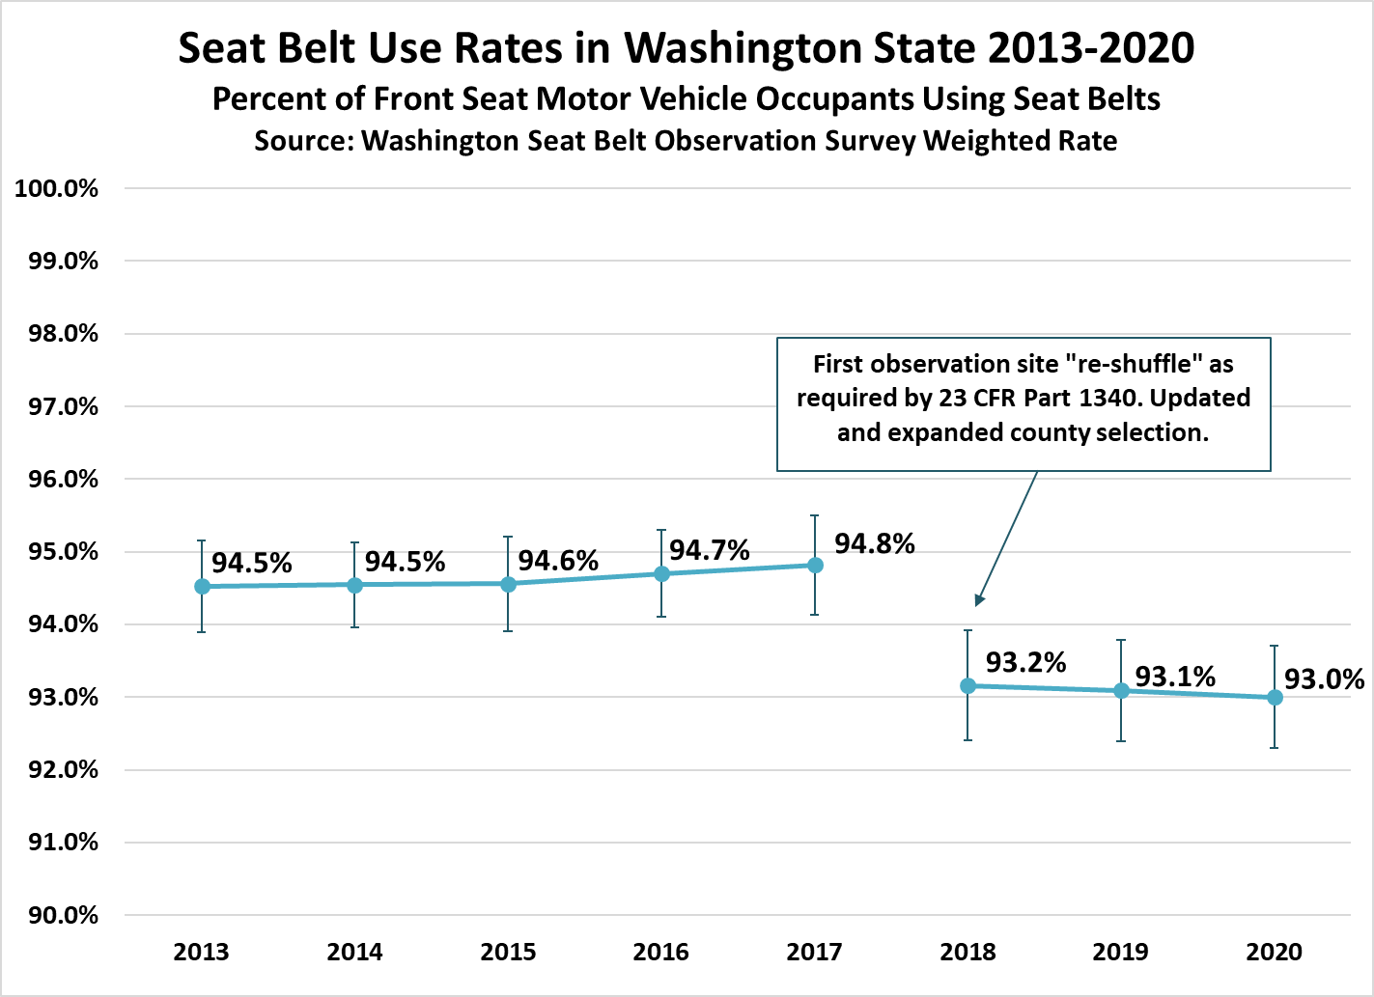

Despite Washington’s high seat belt use rate, people still die on Washington roads who were not buckled up. In 2020:

- The percent of unrestrained fatalities has increased since 2017 – from 18.5% to 20.7% in 2020.
- Of the 560 road deaths in 2020, 116 involved passengers who were unrestrained.

Seat belt use is lowest on county roads at 89.1% compared to 91.4% on city streets and 95% on state routes.

Young Drivers the Least Restrained

- 35% of young drivers who were killed in crashes were not wearing a seatbelt (WTSC Target Zero Performance Dashboard).

- Drivers age 16-25 have the lowest seatbelt use rate of all ages of drivers involved in fatal crashes, according to the 2019 Target Zero State Highway Safety Plan report.

Parents/Guardians Can Make a Difference by Being Road Models

- Research suggests that teens do listen to parents who are involved in their driver training.

- A study published in the Journal of the American Academy of Pediatrics shows that parental involvement leads to safer driving habits, with teens 50% less likely to crash and 50% more likely to buckle up, than teens who perceive their parents as uninvolved.

- The study also showed that teens with involved parents were:
- 71% less likely to drive intoxicated
- 30% less likely to use a cell phone when driving
Resources for families:

Flyer for Parents/Guardians

https://wadrivetozero.com/car-seats/

Buckle-up to Save Lives

- Seat belts save lives. Your chance of surviving a crash increase by 45% if you are wearing your belt.

- According to the 2019 Target Zero plan, “much of the success in reducing traffic fatalities and serious injuries has occurred because of vehicle design and seat belt use.”

- Nationally, seat belts saved an estimated 14,955 lives in 2017, according to the National Highway Traffic Safety Administration.

De-Bunking a False Sense of Security

It’s easy to buy-in to common misperceptions of security (statistics below are national):

- Big vs. Small: If you’re not buckled up, being in a pickup or other large vehicle isn’t safer. In fact, 61% of pickup truck occupants who were killed in 2016 were not buckled up. That’s compared to 42% of passenger car occupants who were not wearing seat belts when they were killed. Big truck or small car, seat belts are the safest bet.

- Front Seat vs. Back Seat: Too many people wrongly believe they are safe in the back seat unrestrained. Forty-seven percent of all front-seat passenger vehicle occupants killed in crashes in 2016 were unrestrained, but 57% of those killed in back seats were unrestrained. If you’re in the back, buckle-up.

- Rural Road vs. City Street: People who live in rural areas might believe that their crash exposure is lower, but in the U.S. in 2016, there were 13,732 passenger vehicle fatalities in rural locations, compared to 9,366 fatalities in urban locations. Out of those fatalities, 49% of those killed in the rural locations were not wearing their seat belts, compared to 46% in urban locations. Whether on busy city streets or a dusty rural road, buckle up to stay safe.

###

