Social Text | Graphic Text
Riders must create their own safety. Wear a helmet, ride sober, go safe speeds, take advantage of training.  https://itsafineline.com/motorcycle-training/ | 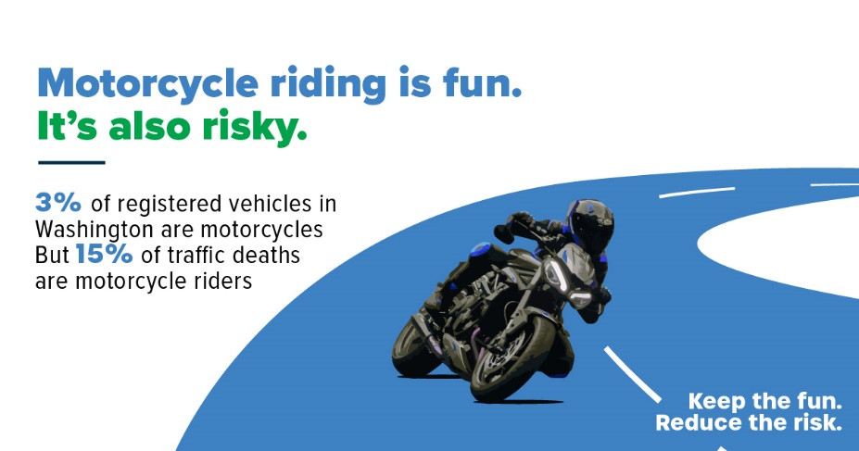
Riders must create their own safety.  https://itsafineline.com/motorcycle-training/ | 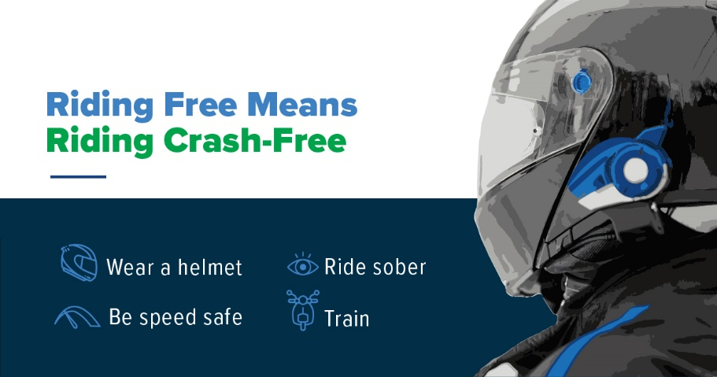
We can all work together to save lives. | 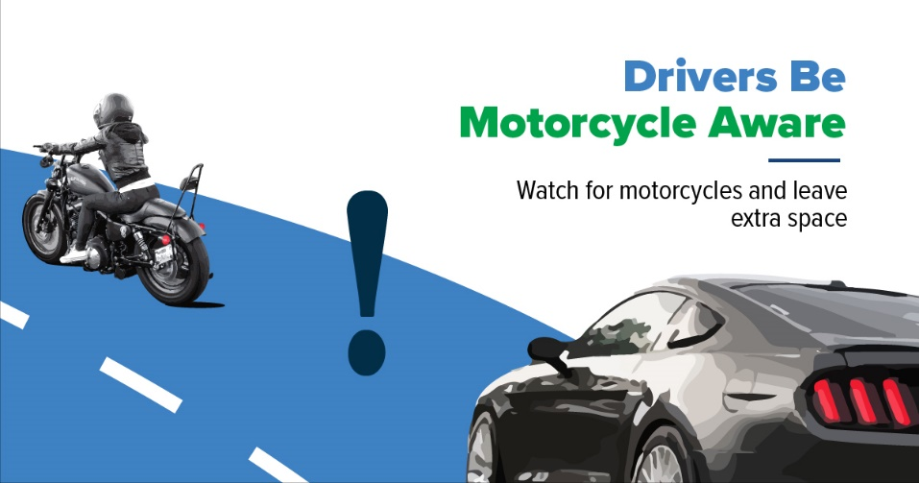
Only 3% or all registered vehicles in Washington are motorcycles. But motorcyclists were 15% of total traffic deaths.  There are safety classes that help. Find one near you.  https://itsafineline.com/motorcycle-training/ | 