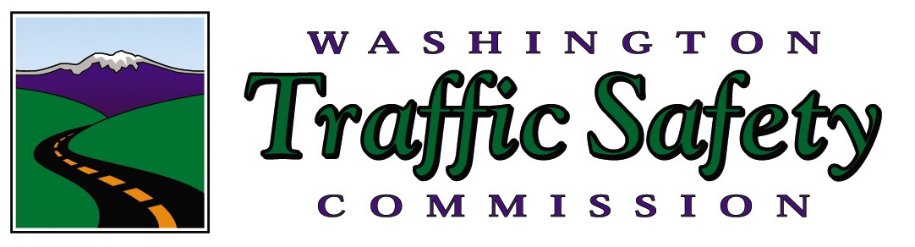
FOR IMMEDIATE RELEASE
July 5, 2021

Contact:
Mark Medalen, WA Traffic Safety Commission, mmedalen@wtsc.wa.gov, 360-280-8008

Motorcycle safety patrols begin July 9

OLYMPIA, WA — More motorcycles travel on Washington’s roads in the summer months than any other time of the year. Unfortunately, summer is also the time when more motorcycle riders are killed or injured in crashes. In an effort to reduce these crashes, increased motorcycle safety patrols start July 9, and run through July 25 in Pierce, King, Snohomish, Clark, Yakima, and Spokane Counties.

The patrols will focus on illegal driving behaviors by both motorcycle riders and other vehicle drivers. Approximately 25 law enforcement agencies in these counties, including the Washington State Patrol, will be working overtime focused on drivers and riders who commit traffic safety violations.

In 2019 and 2020, over 90 motorcycle riders died each year in crashes on Washington’s roads. This was the highest number of motorcycle rider fatalities in a single year in our state since 1982.

"We are concerned about the high number of motorcycle rider deaths and we know that we can all work to prevent these deaths,” said Shelly Baldwin, Director of the Washington Traffic Safety Commission. “These crashes are preventable.”

These patrols are part of the Washington Traffic Safety Commission’s (WTSC) motorcycle safety education campaign known as “It’s a Fine Line.” From 2016 through 2020, motorcycles made up just 3 percent of the registered vehicles on Washington’s roads, but accounted for 15 percent of all traffic fatalities (419 of 2,723). While about 2/3 of fatal motorcycle crashes involved another vehicle, illegal and dangerous actions by the rider including speeding, losing control in corners and curves, improper passing, and riding under the influence of alcohol and/or drugs were the main contributing factors cited in these crashes.

“Each summer in our state, we lose 35-40 people to motorcycle crashes, and that’s not acceptable,” Baldwin added. "Drivers can watch out for motorcyclists. Riders can improve their skills through training. All of us can respect speed limits and ride and drive sober."

The National Highway Traffic Safety Administration (NHTSA) reported that motorcycle fatalities across the country decreased .5 percent from 5,038 in 2018 to 5,014 in 2019. Per vehicle mile traveled in 2019, motorcyclists were about 29 times more likely than passenger vehicle occupants to die in a crash and 4 times more likely to be seriously injured.

The WTSC and participating law enforcement agencies condemn profiling. Trained and commissioned law enforcement officers will be conducting these patrols enforcing traffic violations as defined by Washington State laws.

For training videos and other information on the “It’s A Fine Line” motorcycle safety program in Washington, please visit http://itsafineline.com/
These and all extra law enforcement patrols are part of Target Zero—striving to end traffic deaths and serious injuries in Washington by 2030. For more information, visit www.targetzero.com. Additional information on the Washington Traffic Safety Commission can be found on the website, www.wtsc.wa.gov.

https://www.youtube.com/user/itsafinelinewa/videos

###

