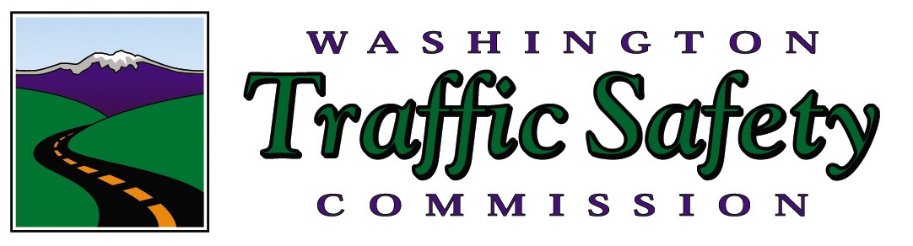
FOR IMMEDIATE RELEASE
July 8, 2021

Contacts:

Sara Wood, King County Target Zero, swood@kentwa.gov, 253-856-5851

Renee Tinder, Pierce County Target Zero, TZMRegion5@outlook.com, 253-906-0522

Stacey McShane, Snohomish County Target Zero, Stacey.mcshane@snoco.org, 425-388-3817

Mark Medalen, WA Traffic Safety Commission, mmedalen@wtsc.wa.gov, 360-280-8008

Motorcycle safety patrols begin July 9

OLYMPIA, WA — More motorcycles travel on Washington’s roads in the summer months than any other time of the year. Unfortunately, summer is also the time when more motorcycle riders are killed or injured in crashes. In an effort to reduce these crashes, increased motorcycle safety patrols will occur this weekend July 9 through July 11 in Pierce, King, and Snohomish Counties as part of the Washington Traffic Safety Commission’s motorcycle safety emphasis campaign running through July 25.

The patrols will focus on illegal driving behaviors by both motorcycle riders and other vehicle drivers. Approximately 40 law enforcement agencies in these counties, including the Washington State Patrol, will be working overtime focused on drivers and riders who commit traffic safety violations.

In 2020, of the 789 crashes involving motorcycles in these three counties, 176 people sustained serious injuries and 37 riders died. This contributed to over 1/3 of all motorcycle rider deaths on Washington’s roads for the year.

"We are concerned about the high number of motorcycle rider deaths and we know that we can all work to prevent these deaths,” said Shelly Baldwin, Director of the Washington Traffic Safety Commission. “These crashes are preventable.”

“Each summer in our state, we lose 35-40 people to motorcycle crashes, and that’s not acceptable,” Baldwin added. "Drivers can watch out for motorcyclists. Riders can improve their skills through training. All of us can respect speed limits and ride and drive sober."

These patrols are part of the Washington Traffic Safety Commission’s (WTSC) motorcycle safety education campaign known as “It’s a Fine Line.” From 2016 through 2020, motorcycles made up just 3 percent of the registered vehicles on Washington’s roads, but accounted for 15 percent of all traffic fatalities (419 of 2,723). While about 2/3 of fatal motorcycle crashes involved another vehicle, illegal and dangerous actions by the rider including speeding, losing control in corners and curves, improper passing, and riding under the influence of alcohol and/or drugs were the main contributing factors cited in these crashes.

The WTSC and participating law enforcement agencies condemn profiling. Trained and commissioned law enforcement officers will be conducting these patrols enforcing traffic violations as defined by Washington State laws.

For training videos and other information on the “It’s A Fine Line” motorcycle safety program in Washington, please visit http://itsafineline.com/
These and all extra law enforcement patrols are part of Target Zero—striving to end traffic deaths and serious injuries in Washington by 2030. For more information, visit www.targetzero.com. Additional information on the Washington Traffic Safety Commission can be found on the website, www.wtsc.wa.gov.

https://www.youtube.com/user/itsafinelinewa/videos

###

