AUGUST 2021 Impaired Driving Campaign
SOCIAL MEDIA MESSAGES/GRAPHICS

Here are sample messages and graphics that you can download and use in your social media.

DUI Patrols are on and dedicated to the memory of Officer Mark Brinkman. He saved countless lives by keeping drunk drivers off the road. | 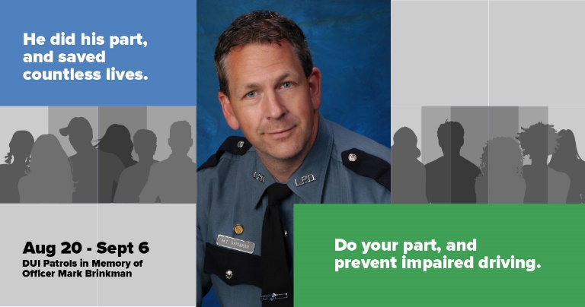
Your couch can be a lifesaver. Let someone spend the night there rather than drive drunk or high. | 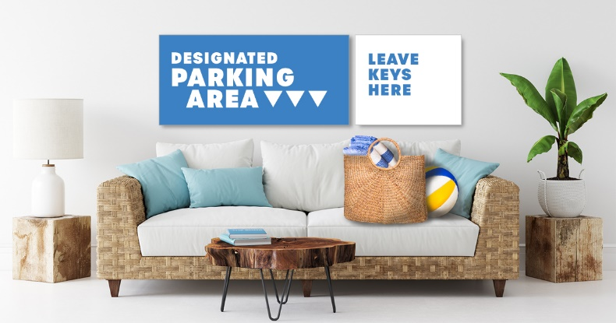
Deaths from DUI crashes are increasing in Washington. | 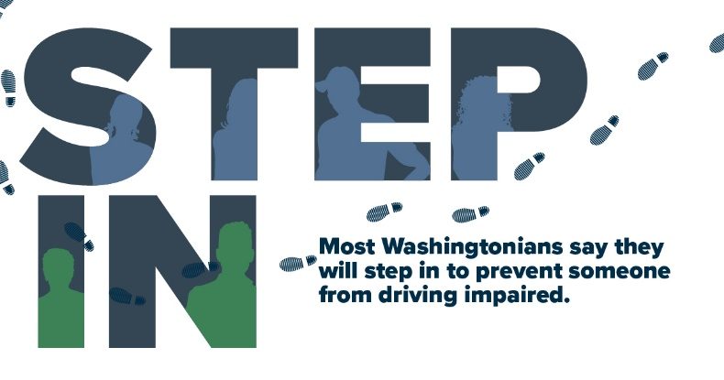
If someone you know is about to drive impaired, here’s what you can do. | 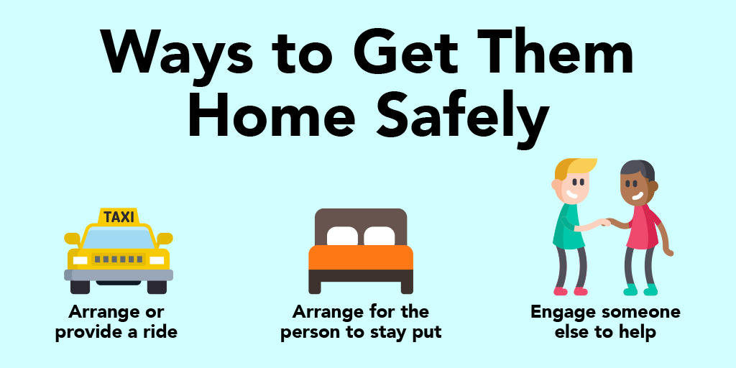
Traffic deaths and serious injuries continue to increase at alarming rates in 2021 as more Washingtonians return to the roads. | 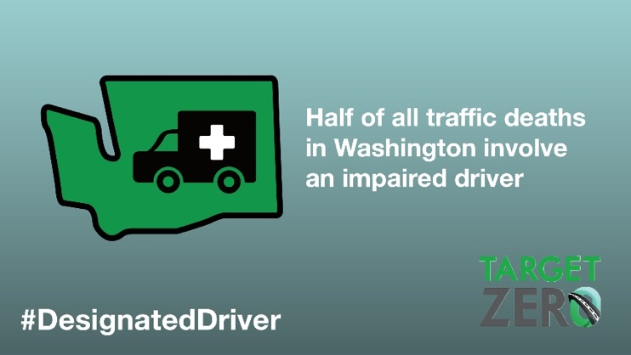
Take this simple quiz. So, how did you do? | 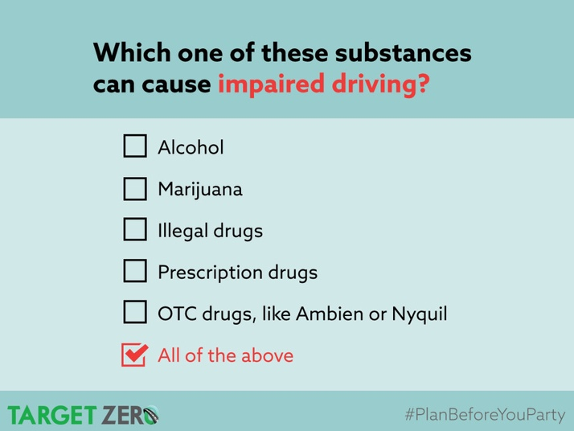
Be like most Washingtonians and never drive after drinking. | 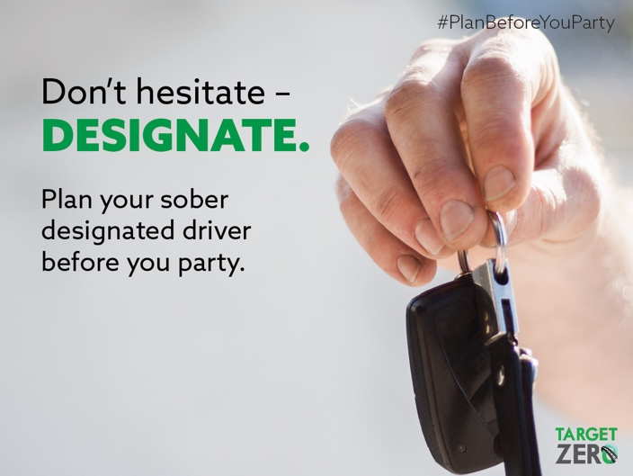
When there’s a chance to prevent someone from driving impaired, most Washingtonians (81%) will intervene and act. | 