2021 Holiday DUI Campaign

Key Messages and Facts

- 2020 was one of the deadliest years in Washington from DUI-related crashes, despite fewer drivers on the road.

- Preliminary data for 2021 also indicates an increase in deaths this year from driver impairment.

- As Washington prepares to celebrate the holiday season, let’s all do our part for sober driving. Be sober behind the wheel and prevent someone you care about from getting a DUI.

- We can reverse the alarming trend in deaths and injuries from DUIs if we all work together.

- Most people in Washington – 78% – never drink before driving. That’s a choice that’s easy to live with.

- We can help protect our friends and families too, by preventing someone from driving while impaired. Most Washingtonians – 81% – say they will step in to prevent someone from driving drunk or high.

- You’d reach out to stop a friend from falling or getting hurt from an unseen danger. We do the same when we stop people we love from driving drunk or high.

Effective Ways to Stop Someone from Driving Drunk or High
- If you encounter a situation where someone might drive impaired, you can:
  - Arrange for or provide a ride
  - Arrange for the person to stay where they are
  - Offer your couch for the night
  - Engage someone else to help, including calling 911

- Calling 911 to prevent a crash is better than calling to report one. Taking action to prevent a DUI-related crash is an emergency.

- When talking to 911 dispatchers, they will want to know the following (without putting yourself in danger):
  - the make and model of the car
  - license plate number
  - route and direction being travelled
  - a description of the driver

Fewer Drivers but More DUIs, Crashes and Deaths

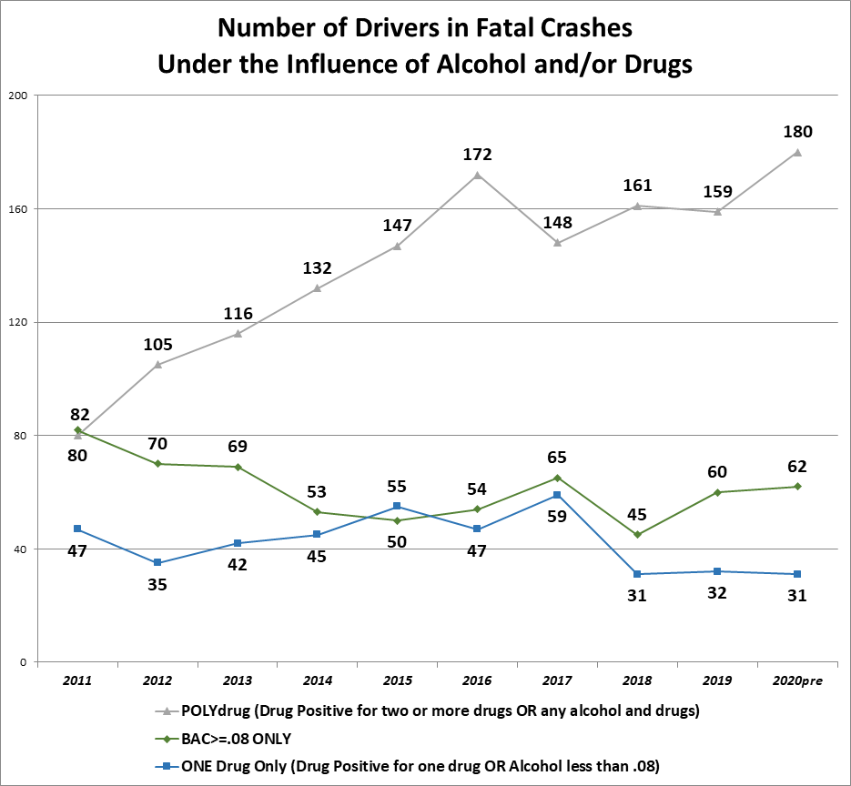
- 2020 had the highest number of polydrug drivers in fatal crashes, ever (and highest number of impaired drivers by either alcohol or drugs).

- August 2021 was the deadliest month on Washington’s roads (77 deaths) since 1997 (91 deaths).

- Vehicle Miles Traveled (VMT) in 2020 was down 15% compared with 2019, and at times as low as 60% less.

- At the same time, fatalities in DUI- involved crashes increased 12.4% and serious injuries increased 32.4% over 2019.

- Traffic fatalities and serious injuries continue to increase at alarming rates in 2021 as more Washingtonians return to the roads.

###

