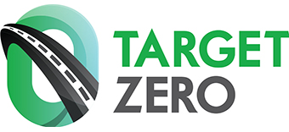
2021 Holiday DUI Campaign
Sample Social Media Posts
The following are sample graphics and related content that we encourage you to use on your organization’s social media. Feel free to adapt for use on your website or customized emails too.
81% say they will stop someone from driving drunk or high. Will you?
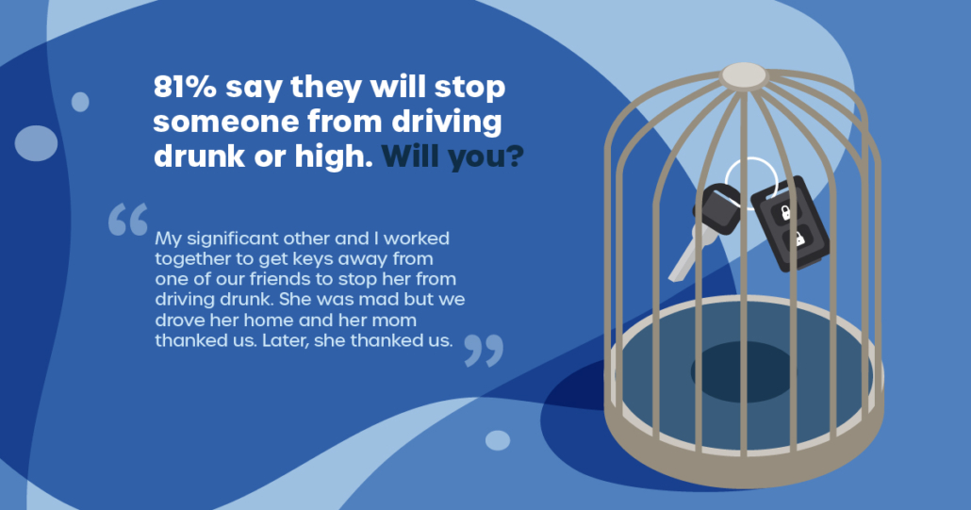
Most of us say we will stop someone from driving drunk or high. Will you? 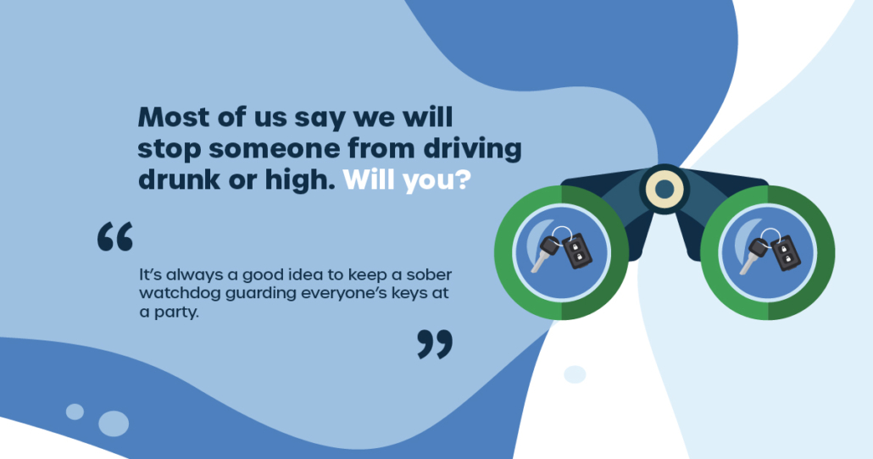
81% say they will stop someone from driving drunk or high. Will you?
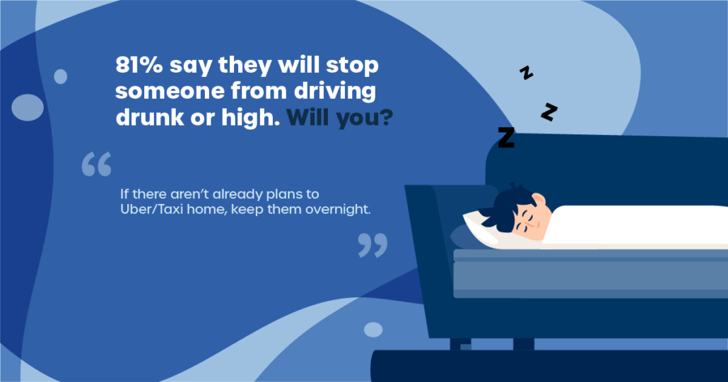
81% say they will stop someone from driving drunk or high. Will you?
