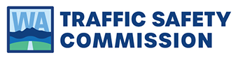

For Immediate Release | Contact
March 31, 2022 | Erika Mascorro  Washington Traffic Safety Commission  (360) 791-0280  emascorro@wtsc.wa.gov

Distracted Driving Rate Falls in Washington

Olympia – Washington’s distracted driving rate fell in 2021, from 9.4 percent in 2020 to 6.9 percent, according to the Washington Traffic Safety Commission’s (WTSC) Annual Distracted Driving Observation Survey. Officials said the decline was welcome news to mark the beginning of April as Distracted Driving Awareness Month. Law enforcement agencies across the state will be conducting emphasis patrols, with the aid of spotters on foot looking for motorists who continue to drive distracted.

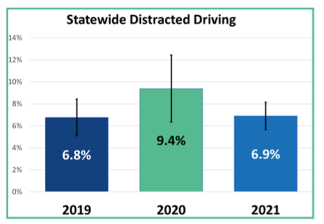
“Focused driving means safer roads,” said Erika Mascorro, WTSC Program Manager for Distracted Driving. “The decline in distracted drivers gives us something to cheer as we kick-off distracted driving month. Seeing more people focused on driving is motivation to get all of us off the phone when we’re on the road.”
According to WTSC’s 2021 Distracted Driving Observational Survey, distracted driving rates across the state fell to pre-pandemic levels in 2021.

The distracted driving rate climbed nearly three points in 2020 over 2019. In 2021 the rate declined to its pre-pandemic level. Device use (hand-held or device to the ear) is the most common source of driver distractions. Distraction is highest on city streets and lowest on state routes. In 2017, the legislature passed Washington’s current distracted driving law, which prohibits hand-held cell phone use while driving, stopped in traffic, or while at a stop light. Since the law was passed, distracted driving deaths have decreased 40 percent, from 155 in 2017 to 93 in 2020.

“People save lives when they turn off their phones before they start their cars,” said Mascorro. “Make focused driving a habit by putting your phone in the glove box, by taking 10 minutes before you drive to catch up on phone calls or text messages, or by setting up music or navigation before you drive. We can refuse, like most Washington drivers, to let our phones endanger our lives.”

While distracted driving rates are down, more than 80 law enforcement agencies statewide will be adding patrols focused on finding drivers whose attention is not on driving. The patrols run April 4th through the 11th and will employ officers in patrol cars working in tandem with “spotters” on foot at intersections and other places where drivers are tempted to distract themselves by peeking at their phones.

Research shows that it can take a driver 27 seconds to refocus on the road after using a cell phone, the time it can take to drive the length of three football fields in a car moving at 25 mph.

“Our hope is that all Washington drivers will choose to put focus first. Distracted Driving Awareness month is a great time to begin a lifelong habit of putting your phone away before you drive,” Mascorro said. “And the decline in distracted driving over the past year should encourage all of us to do it.”

###

