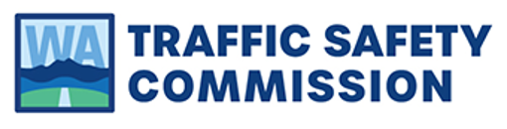
For Immediate Release | Contact
May 9, 2023 | Mark McKechnie  External Relations Director  Washington Traffic Safety Commission  (360) 725.9889  mmckechnie@wtsc.wa.gov

Washington Traffic Safety Commission to increase seat belt patrols beginning May 15

OLYMPIA — Washington Traffic Safety Commission (WTSC) supports annual law enforcement campaigns to increase seat belt use. This year’s campaign will be May 15 through June 4. Seat belt use plays a critical role in reducing the severity of traffic-related injuries and remains a national and Washington state priority. Since 2015, approximately one in five fatalities were unrestrained vehicle occupants. Early 2022 estimates suggest an upward trend in fatal and serious crashes involving unrestrained occupants.
Following a slight decrease from 94.2% to 93.9% in seat belt use among Washingtonians in 2022, the upcoming seat belt patrol aims to increase seat belt use and prevent traffic-related injuries and fatalities. “Our goal is not to write more tickets but to remind drivers of the importance of seat belt use and to ensure safety for everyone on the road,” said Mark McKechnie, External Relations Director at WTSC.
In order to help people remember to buckle up and avoid a ticket, WTSC is running their “However You Say It” campaign, which uses easy and friendly examples to help remind everyone to buckle up. A Spanish-language campaign, “Loteria,” will also run. These ads will air on social media, TV and radio, and video and audio streaming services in an effort to underscore this message throughout the state.
McKechnie shared, “Most Washingtonians buckle up when they're on the road. And it's easy to remind the people you ride with to do it, too. You never know when that simple reminder could save a life.”
For more information about seat belt use in Washington state, explore WTSC’s 2022 report or visit https://www.togetherwegetthere.com/seat-belts/.

###
About the Washington Traffic Safety Commission
The Washington Traffic Safety Commission (WTSC) is Washington’s designated highway safety office. WTSC leads statewide efforts and builds partnerships to save lives and prevent injuries on Washington roadways for the health, safety and benefit of communities. In coordination with numerous other state and local public agencies, the commission aims to reduce traffic fatalities and serious injuries to zero by 2030.

